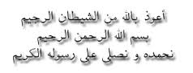

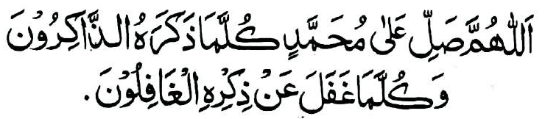

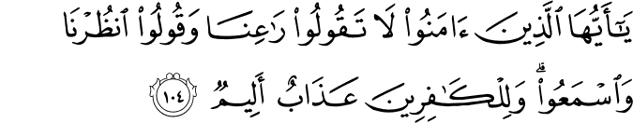

O You Who Believe!

Approved by: Maulana Bashir Ahmed Diwan
Auckland, New Zealand

Compiled by: R. Diwan

Dhul Hijjah 1435 – September 2014 (2nd Print)
Reprint: Rabi’ul Awwal 1438 – December 2016

Bismillahir Rahmanir Raheem

The Arabian Messenger, Hadhrat Muhammad Sallallahu Alaihi Wasallam brought the message, the Qur’aan Majeed, in the Arabic language for our guidance. We need to understand the message. The least we can do is to understand those Ayaat directly which are addressed to us. They are those that begin with
‘Ya ayyuhal ladhina amanū’ - ‘O you who believe!’
‘Ibn Abi Hatim Rahimahullah recorded that a man came to Abdullah bin Mas’ud Radiallahu Anhu and said to him, ‘Advise me’. He said, ‘When you hear Allah’s statement, ‘O you who believe!’ then pay full attention, for it is a righteous matter that Allah is ordaining or an evil thing that He is forbidding’.
This booklet is a compilation of the English translation of these Ayaat, 89 in total.
The phrase ‘O you who believe!’ begs the question ‘Believe in what?’ The answer to this is in Ayah An-Nisā’ 4.136:
‘... Believe in Allah, and His Messenger, and the Book which He revealed upon His Messenger...’.
The explanations of the Ayaat are from Tafseer-ibn-Katheer.

Religion – Way of Life
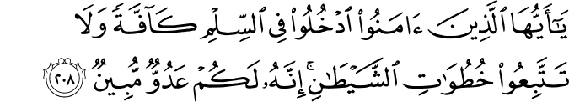
O you who believe! Enter into Islam (silm) completely and do not follow the footsteps of shaitaan. Indeed! He is to you an open enemy. Al-Baqarah 2.208 (1)
Islam is synonymous with the word ‘silm’, and it means ‘submission’ to Allah. ‘Udkhulu fis silmi kaaffah’ – means to enter into Islam completely. This carries two meanings:
- To enter into Islam completely, physically as well as mentally, leaving out all other beliefs and practices.
- To accept all rules and regulations of Islam relating to belief, worship, character, social and financial dealings (Aqaa’id, Ibadaat, Akhlaaq, Mu’amalaat and Muasharat).
The phrase ‘the footsteps of shaitaan’ [khutuwatish shaitaan] appears in the Qur’aan Majeed five times [2.168, 2.208, 6.142 and twice in 24.21]. Shaitaan’s refusal to obey Allah, being arrogant [2.34] and being ungrateful to Allah [17.27], and commanding evil - soo’ and fahsha’ and munkar [2.169, 2.268, 24.21] inciting dissension, enmity, hatred among the people [17.53, 5.91] and disbelief in Allah [59.16] - are the footsteps of shaitaan.

Obey Allah and His Messenger
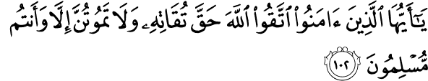
O you who believe! Fear Allah as is His right that He should be feared, and die not except as Muslims. Ál-‘Imrān 3.102
Abdullah bin Mas’ud Radiallahu Anhu commented on the Ayah ‘Fear Allah [have Taqwa] as is His Right’ that ‘He is obeyed and not defied, remembered and not forgotten, and appreciated and not unappreciated’. ‘And die not except as Muslims’ means preserve your Islam while you are well and safe, so that you die as a Muslim, as one who has submitted to the Will of Allah.

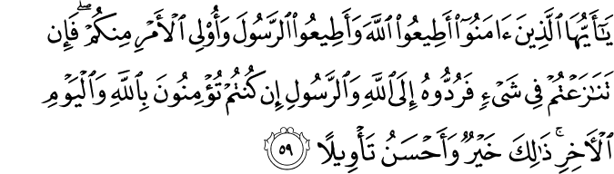
O you who believe! Obey Allah and obey the Messenger, and those having authority among you. Then if you disagree about anything, refer it to Allah and the Messenger, if you indeed believe in Allah and the Last Day. That is best and more suitable (for final) determination. An-Nisā’ 4.59
Adhere to the Book of Allah and adhere to the Sunnah of the Messenger, and obey those in authority in the obedience of Allah which they command you. Obedience to those in authority is only in righteous deeds. There is no obedience to anyone in disobedience to Allah Ta’ala. Obedience to those in authority is, therefore, conditional.
The four sources of Islamic Law have been derived from this Ayah – follow the Qur’aan, the Sunnah, the Ijma and Qiyaas. Ijma is agreeing upon or uniting in opinion. Qiyaas is the process of finding a solution to an issue using the concept of analogy.

O you who believe! Believe in Allah and His Messenger, and the Book which He revealed upon His Messenger, and the Book which He revealed from before. And whoever disbelieves in Allah, and His Angels, and His Books, and His Messengers, and the Last Day, then surely he has lost the way, straying far away. An-Nisā’ 4.136

O you who believe! Obey Allah and His Messenger, and do not turn away from him while you hear (him speak). Al-Anfāl 8.20
Neither refrain from obeying the Messenger or following his commands nor indulge in what he forbade, after you have gained knowledge of his message.

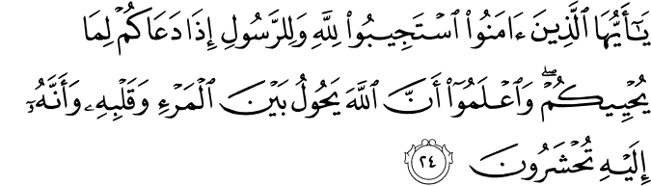
O you who believe! Respond to Allah and His Messenger when he calls you to that which gives you life. And know that Allah comes between a man and his heart, and that to Him you will be gathered. Al-Anfāl 8.24
Imam Bukhari Rahimahullah said ‘That which gives you life’ means that which will make your affairs good. ‘Allah comes between a man and his heart’ means a person will neither believe nor disbelieve except by Allah’s leave. Rasulullah Sallallahu Alaihi Wasallam often made this Du’aa:
‘Ya muqallibal quloob! Thabbit qalbi ‘ala deenik’.
O You Who changes the hearts, make my heart firm on Your religion.
It is only God consciousness that can prevent a man from the sinful desires of his heart. (Message of the Qur’aan)

O you who believe! Do not betray Allah and His Messenger, or knowingly betray your trusts. Al-Anfāl 8.27
Betrayal includes both minor and major sins, as well as those that affect others.

O you who believe! If you fear Allah, He will grant you a criterion (Furqaan) and will remove from you, your evil deeds and forgive you. And Allah is the Possessor of Great Bounty.
Al-Anfāl 8.29
Allah Ta’ala will grant you a criterion - the ability to differentiate between truth and falsehood.

O you who believe! Remember Allah with much remembrance. Al-Ahzāb 33.41
And glorify Him morning and evening. Al-Ahzāb 33.42

O you who believe! Do not enter the houses of the Prophet except when permission is given to you for a meal, without awaiting its preparation. But when you are invited, then enter; and when you have eaten, then disperse and do not seek to remain for a conversation. Indeed, that was troubling the Prophet, and he was shy of (dismissing) you. But Allah is not shy of the truth. And when you ask them (his wives) for anything then ask them from behind a screen (Hijaab). That is purer for your hearts and their hearts. And it is not for you that you trouble the Messenger of Allah and that you should not marry his wives after him, ever. Indeed, that is near Allah an enormity. Al-Ahzāb 33.53
This is the Ayah of Hijaab, which includes several legislative rulings and points of etiquette.

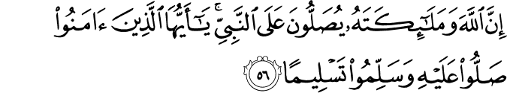
Indeed, Allah and His Angels send blessings (Salaah) upon the Prophet. O you who believe! Send blessings (Salaah) on him and greet (Salaam) him with greetings. Al-Ahzāb 33.56
The Salaah of Allah is the sending of mercy and His praising him before the angels, the Salaah of the angels is their supplication of forgiveness, and the Salaah of the believers is their praying for Nabi Sallallahu Alaihi Wasallam. Occasions for us to say Salaah upon Rasulullah Sallallahu Alaihi Wasallam: following the call to Prayer (Adhan), when entering or exiting the Masjid, five times daily Salaah, Janazah Salaah, before, during and after Du’aa, and on the day of Jumu’ah. Salaah (blessings) is in Darood Ibrahim and Salaam (greetings) is in ‘Attahayyāt’, both of which are recited in every Salaah.

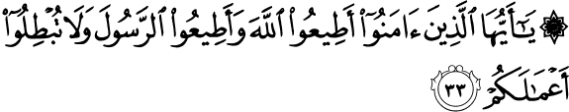
O you who believe! Obey Allah, and obey the Messenger and do not make vain your deeds. Muhammad 47.33
Do not invalidate and destroy your deeds by apostasy (turning away from Islam). Apostasy wipes away good deeds entirely, just as good deeds would normally wipe away evil deeds.
‘Riyā’ – to perform deeds to please Allah Ta’ala as well as others also destroys deeds.

O you who believe! Do not put (yourselves) forward before Allah and His Messenger and fear Allah. Indeed, Allah is All-Hearer, All-Knower. Al-Hujurāt 49.1
Abdullah Ibn Abbas Radiallahu Anhu said it means do not say anything that contradicts the Qur’aan and the Sunnah. It also means do not rush in making decisions about the Messenger, rather, follow his lead in all matters.

O you who believe! Do not raise your voices above the voice of the Messenger, and do not be loud to him in speech like the loudness of some of you to others, lest your deeds become worthless while you perceive not. Al-Hujurāt 49.2

O you who believe! Fear Allah and believe in His Messenger. He will give you a double portion (kiflain) of His Mercy, and He will make for you a light, you will walk with it, and He will forgive you. And Allah is Oft-Forgiving, Most Merciful.
Al-Hadìd 57.28 (4)
Abdullah Ibn Abbas Radiallahu Anhu said that this Ayah is about the People of the Scriptures who believe in Islam, that they will earn double their reward. Rasulullah Sallallahu Alaihi Wasallam said a believer from the people of the Scriptures who has been a true believer in his Prophet and then believes in me, will get a double reward. The second explanation is that it is addressing the Muslims – one reward for giving up disbelief and turning to Islam, and the second reward for believing sincerely in Islam and remaining steadfast to it. Umar bin Al-Khattab Radiallahu Anhu asked a Jewish Rabbi, ‘What is the maximum a reward would be increased for you? He replied ‘A kifl (portion) which is about 350 merits. So Umar Radiallahu Anhu said, ‘Praise be to Allah who gave us two kifls’.

O you who believe! When you hold secret counsel (najwah), then do not hold secret counsel for sin and aggression and disobedience to the Messenger, but hold secret counsel for righteousness and piety. And fear Allah, to Whom you will be gathered. Al-Mujādilah 58.9
Secret counsels are only from shaitaan, so that he may cause grief to the believers.

O you who believe! When you privately consult the Messenger, then offer before the private consultation, charity. That is better and purer for you. But if you find not (the means for it), then indeed, Allah is Oft-Forgiving, Most Merciful.
Al-Mujādilah 58.12
Offering charity cleanses and purifies him and makes him worthy of having a private counsel with Nabi Sallallahu Alaihi Wasallam.
Patience, Jihād and Striving in the Path of Allah

O you who believe! Seek help through patience (sabr) and Prayer (Salaah). Indeed! Allah is with the patient.
Al-Baqarah 2.153
The best tools to help ease the effects of afflictions are patience and prayer. There are three types of patience - one for avoiding prohibitions and sins even if you desire them, one for acts of worship and obedience even if they are hard on you, and the mandatory one in the face of afflictions and hardships.

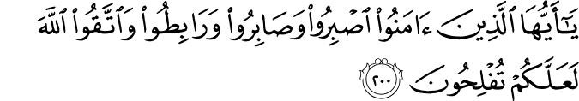
O you who believe! Be steadfast and patient and constant, and fear Allah so that you may be successful. Ál-‘Imrān 3.200
Endure and be more patient and persevere. Endure the enemies and the disbelievers, be patient in the religion that Allah chose for you, Islam, and persevere against the enemies.

O you who believe! Take your precautions and advance in groups, or advance all together. An-Nisā’ 4.71
This Ayah stresses the necessity of taking precautions against the enemies.

O you who believe! When you go forth in the Way of Allah, then investigate, and do not say to the one who offers to you (a greeting of) peace, ‘You are not a believer’; seeking the transitory gains of the worldly life. With Allah are abundant booties. You were like that from before, and then Allah conferred favour upon you; so investigate. Indeed, of what you do, Allah is All-Aware. An-Nisā’ 4.94

O you who believe! Remember the Favour of Allah upon you when a people determined to stretch towards you, their hands, but He restrained their hands from you. And fear Allah. And upon Allah let the believers put their trust. Al-Mā’idah 5.11

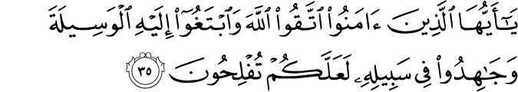
O you who believe! Fear Allah and seek towards Him the means (of approach) and strive hard in His way, so that you may succeed. Al-Mā’idah 5.35
Commanding Taqwa, Waseelah and Jihād. Qatadah Rahimahullah said to seek the means of approach to Him by obeying Him and performing the acts that please Him. Fear Allah means to fear the displeasure of Allah, to fear the wrath of Allah.

O you who believe! When you meet those who disbelieve, advancing, then do not turn your backs to them. Al-Anfāl 8.15
Fleeing from the battlefield is prohibited unless it is a stratagem of war or a retreat to a troop of your own. Fleeing is considered a major sin. Allah’s wrath is upon him, and his abode is Hell.

O you who believe! When you meet a force, then be firm and remember Allah much, so that you may be successful.
Al-Anfāl 8.45

O you who believe! What is the matter with you, when it is said to you to go forth in the Way of Allah, you cling heavily to the earth? Are you pleased with the life of this world rather than the Hereafter? But what is the enjoyment of the life of this world in comparison to the Hereafter, except a little. At-Taubah 9.38
This Ayah admonishes clinging to this life rather than going forward to perform Jihād.

O you who believe! Fight those of the disbelievers who are close to you, and let them find harshness in you, and know that Allah is with those who fear Him. At-Taubah 9.123

O you who believe! Remember the Favour of Allah upon you, when there came against you hosts, and We sent upon them a wind and hosts which you could not see. And Allah is of what you do, All-Seer. Al-Ahzāb 33.9
This Ayah is referring to the campaign of the confederates [Al-Ahzāb / Al-Khandaq]

O you who believe! If you help Allah, He will help you, and make your feet firm. Muhammad 47.7
If you support Allah’s Cause, He will then support you.

O You who believe! Shall I guide you to a business that will save you from a painful torment? As-Saff 61.10
It is to believe in Allah and His Messenger and strive in the Way of Allah with your wealth and your lives. That is better for you if you but know. As-Saff 61.11

O you who believe! Be helpers of Allah as Isa, son of Maryam said to the disciples: ‘Who are my helpers for Allah?’ Said the disciples: ‘We are the helpers of Allah.’ Then a group of the Children of Israel believed and a group disbelieved. So We supported those who believed against their enemy, and they became dominant. As-Saff 61.14 (5)
This dominance was achieved through the victory that Hadhrat Muhammad Sallallahu Alaihi Wasallam gained over the religion of the disbelievers. Allah the Exalted ordered His faithful servants to be Allah’s supporters at all times, in all their statements and actions, sacrificing their selves and wealth. Allah orders them to accept His and His Messenger’s call, just as the disciples did to Nabi Isa Alaihis Salaam’s call.

Do Not Take Disbelievers as Allies
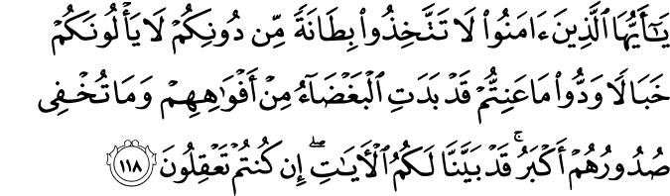
O you who believe! Do not take as allies (bitaanah) from other than yourselves; they will not spare you any ruin. They wish what distresses you. Indeed, the hatred has become apparent from their mouths, and what their breasts conceal is greater. Certainly, We have made clear to you the Ayaat (signs), if you were to reason. Ál-‘Imrān 3.118
Allah prohibits His believing servants from taking the hypocrites and the disbelievers as intimate friends and advisors [bitaanah].They are those who would not fail to do their best to corrupt you.
Context: The tribes of Aws and Khazraj of Madina who had now embraced Islam were advised against continuing their friendship with the hostile disbelievers.

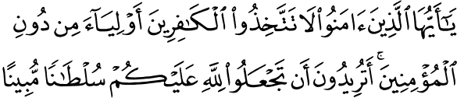
O you who believe! Do not take from the disbelievers allies (awliyaa) instead of believers. Do you wish to make for Allah clear evidence against you? An-Nisā’ 4.144
Allah prohibits His believing servants from taking the hypocrites and the disbelievers as wali – close protecting friends - instead of the believers. Wali (plural ‘awliyaa) means ‘custodian’ ‘protector’ ‘helper’ [Hans Wehr page 1100].

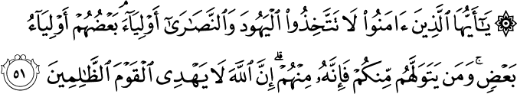
O you who believe! Do not take the Yahud and Nasāra as allies (awliyaa). Some of them are allies to others. And whoever takes them as allies among you, then indeed, he is one of them. Indeed, Allah does not guide the wrongdoing people.
Al-Mā’idah 5.51
Allying oneself with the disbelievers will result in loss of moral identity. This Ayah does not constitute an injunction against normal, friendly relations with such of them as are well disposed towards Muslims. See Surah 60.8-9 (The Message of The Qur’aan) (2)

O you who believe! Do not take those who take your religion in ridicule and fun from those who are given the Book from before you and the disbelievers, as allies (awliyaa). And fear Allah, if you are indeed believers. Al-Mā’idah 5.57
They are those who take the call for Salaah as a mockery and fun. They mock the Salaah and the Adhan.

O you who believe! Do not take your fathers and your brothers as allies (awliyaa) if they prefer disbelief over belief. And whoever takes them as allies among you, then those are the wrongdoers. At-Taubah 9.23
This Ayah prohibits taking the disbelievers as intimates even if they are relatives.

O you who believe! Do not take My enemies and your enemies as allies (awliyaa), offering them affection while they have disbelieved in what came to you of the truth, driving out the Messenger and yourselves because you believe in Allah, your Lord - if you come forth to strive in My Way and to seek My Pleasure. You confide to them affection, but I am most knowing of what you conceal and what you declare. And whoever does it among you, then certainly he has strayed from the Straight Path. Al-Mumtahanah 60.1
Do not take Allah’s enemies and your enemies, those who are actively hostile towards the believers, as intimate and protecting friends.
Context: When the Quraish broke the Treaty of Hudaibiyah, Rasulullah Sallallahu Alaihi Wasallam began secret preparations to invade Makkah. Hatib bin Abi Balta secretly wrote a letter to the pagans of Makkah informing them of the invasion. This letter was intercepted.

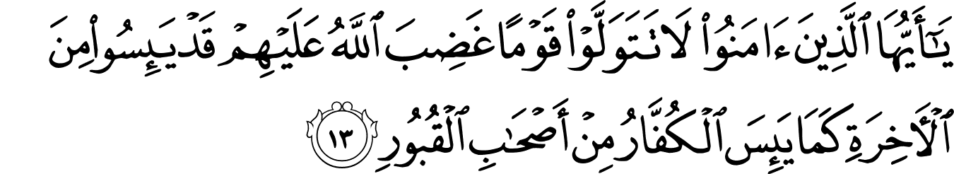
O you who believe! Do not make allies (tatawallaw) of a people upon whom is the Wrath of Allah. Indeed, they despair of the Hereafter, as the disbelievers despair of the companions of the graves. Al-Mumtahanah 60.13
The disbelievers despair of ever again meeting their relatives buried in the graves, because they do not believe in the Resurrection or being brought back to life. Disbelievers who are buried in their graves have lost hope in receiving any recompense, after seeing the punishment and knowing that the Resurrection is true.

Do Not Follow the Disbelievers
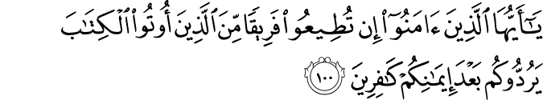
O you who believe! If you obey a group from those who were given the Book, they will turn you back after your belief, as disbelievers. Ál-‘Imrān 3.100

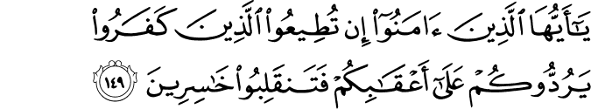
O you who believe! If you obey those who disbelieve, they will turn you back on your heels, and then you will turn back as losers. Ál-‘Imrān 3.149

O you who believe! Do not be like those who disbelieved and they said about their brothers when they travel the earth, or they were fighting: ‘If they had being with us, they would not have died or being killed.’ So Allah makes that a regret in their hearts. And Allah gives life and causes death. And of what you do, Allah is All-Seer. Ál-‘Imrān 3.156
This Ayah prohibits the false creed of the disbelievers regarding death and predestination. No one lives or dies except by Allah’s leave, and no one’s life is increased or decreased except by His decree.

O you who believe! Whoever turns back among you from his religion, then soon Allah will bring a people whom He loves, and they love Him, humble towards the believers and stern towards the disbelievers; striving in the way of Allah and not fearing the blame of a critic. That is the Grace of Allah, He grants whom He wills. And Allah is All-Encompassing, All-Knowing. Al-Mā’idah 5.54

O you who believe! Upon you is to guard yourselves. Those who have gone astray will not harm you when you have been guided. To Allah is your return – all (of you). Then He will inform you of what you used to do. Al-Mā’idah 5.105

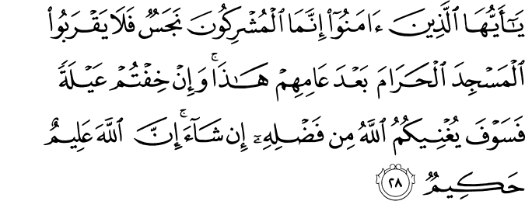
O you who believe! Indeed the polytheists are unclean, so let them not come near al-Masjid al-Haraam after this, their (final) year. And if you fear poverty, then soon Allah will enrich you from His Bounty, if He wills. Indeed, Allah is All-Knower, All-Wise. At-Taubah 9.28 (3)
Disbelievers are no longer allowed in al-Masjid al-Haraam.

O you who believe! Indeed, many of the rabbis and the monks certainly eat the wealth of the people in falsehood, and hinder (them) from the way of Allah. And those who hoard the gold and the silver, and do not spend it in the way of Allah, give them tidings of a painful torment. At-Taubah 9.34
This is a warning against misguided scholars and worshippers, and wealthy hoarders.

Be Custodians of Justice and Truth
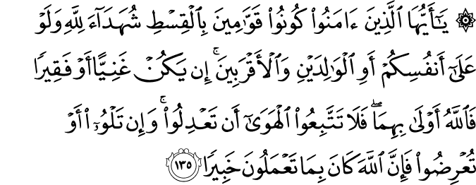
O you who believe! Be custodians of justice, as witnesses to Allah, even if it is against yourselves, or the parents and the relatives, be he rich or poor. Allah is nearer to both of them. So do not follow your desire lest you deviate. And if you distort or refrain, then indeed, of what you do, Allah is All-Aware.
An-Nisā’ 4.135
Allah commands justice and fairness and deliverance of correct testimony and truth. Stand for justice in all situations.

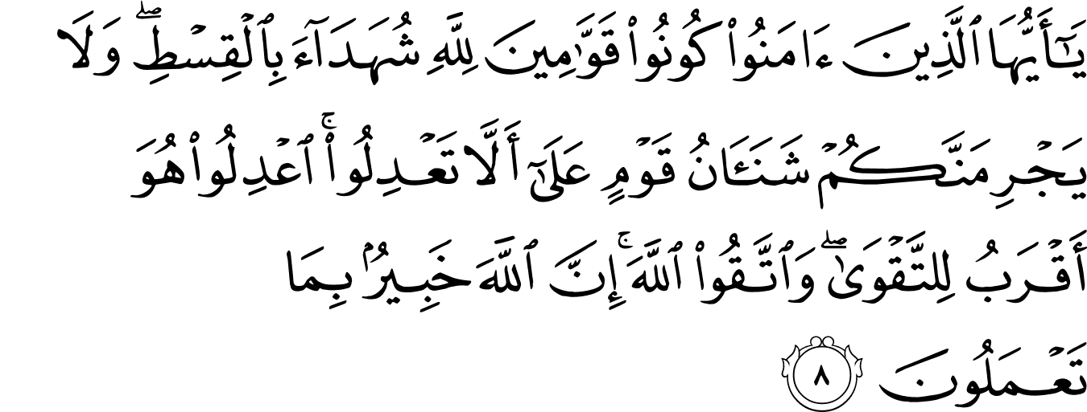
O you who believe! Be steadfast for Allah as witnesses in justice, and let not the hatred of a people prevent you that you do not do justice. Be just, it is nearer to piety. And fear Allah. Indeed, Allah is All-Aware of what you do. Al-Mā’idah 5.8
Be just for the sake of Allah. Be just with everyone, whether a friend or an enemy.

O you who believe! Fear Allah, and be with those who are truthful. At-Taubah 9.119
Hold onto the truth, for being truthful lead to righteousness, and righteousness leads to Jannah.

O you who believe! Fear Allah, and speak the truth (qawl-al-sadīda). Al-Ahzāb 33.70
(He will amend for you, your deeds and forgive for you, your sins. And whoever obeys Allah and His Messenger certainly has attained a great attainment. 33.71)
The expression qawl sadīd signifies, literally, ‘a saying that hits the mark’ that is, is truthful.

Take Care of your Salaah, Saum, Hajj and Charity
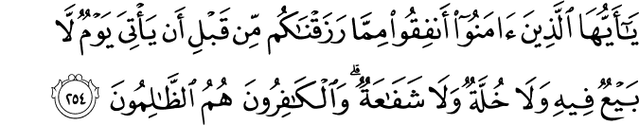
O you who believe! Spend from what We have provided you before there comes a Day of no bargaining in it and no friendship and no intercession. And the disbelievers, they are the wrong-doers. Al-Baqarah 2.254
No injustice is worse than meeting Allah on that Day while a disbeliever. Ibn Abi Hatim recorded that ‘Ata bin Dinar said, ‘All thanks are due to Allah who said, ‘And the disbelievers, they are the wrong-doers’ but did not say ‘And the wrong-doers, they are the disbelievers’.

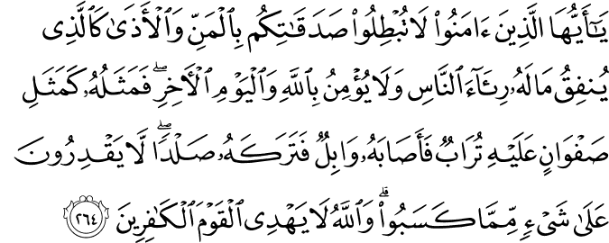
O you who believe! Do not render in vain your charities with reminders or hurt, like the one who spends his wealth to be seen by the people, and he does not believe in Allah and the Last Day. His example is like a smooth rock, upon it is dust, then fell on it heavy rain, and left it bare. They have no control over anything of what they have earned. And Allah does not guide the disbelieving people. Al-Baqarah 2.264
Giving charity to show-off is like sowing a seed on a rock.
In such cases the reward of giving away charity is not sufficient enough to nullify the harm and reminders.

O you who believe! Spend from the good things that you have earned, and whatever We brought forth for you from the earth, and do not aim to spend of the bad of it, while you would not take it except with closed eyes. And know that Allah is Self-Sufficient, Praiseworthy. Al-Baqarah 2.267
How do you agree for Me what you do not agree for yourselves, while I have the right for the best and most precious of your possessions? Although Allah commanded you to give away the purest of your money in charity, He is far Richer from needing your charity, but the purpose is that the distance between the rich and the poor becomes less. Ibn Abbas Radiallahu Anhu said, ‘Allah commanded them to spend from the purest, finest and the best types of their money (lawful earnings) and prohibited spending from evil and dishonestly earned money because Allah is pure and good and only accepts that which is pure and good.

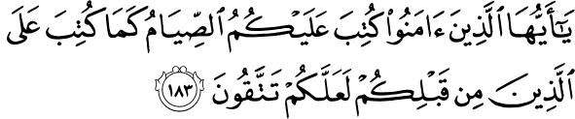

O you who believe! Prescribed for you is the Fasting as was prescribed for those from before you, so that you may become righteous. Al-Baqarah 2.183
Fasting is to abstain from food, drink and sexual activity from dawn to dusk with the intention of doing so sincerely for Allah Alone. Fasting is prescribed because it purifies the soul.

O you who believe! Do not go near Salaah while you are intoxicated until you know what you are saying, and not when you are impure, except when passing through a way, until you have bathed. And if you are ill, or on a journey or one of you come from the toilet, or you have touched the women and you find no water, then do Tayammum with clean earth and wipe (with it) your faces and your hands. Indeed, Allah is Most Pardoning, Most Forgiving. An-Nisā’ 4.43
Contact with women means sexual activity. In Tayammum clean earth is used as a purifier when ill or in the absence of water.

O you who believe! Do not violate the rites of Allah, and not the sacred month, and not the sacrificial animals and not the garlanded and not those coming to the Sacred House, seeking Bounty of their Lord and good pleasure. And when you come out of Ihram then (you may) hunt. And let not the hatred of a people incite you as they stopped you from al-Masjid al-Haraam that you commit transgression. And help one another in righteousness and piety (al-Birr and at-Taqwa), but do not help one another in sin and transgression (Ithm and Udhwaan). And fear Allah; indeed, Allah is severe in punishment. Al-Mā’idah 5.2
The Ayah stresses the necessity of observing the sanctity of the Sacred Area and the Sacred Months. The rites of Allah are the rituals of Hajj and whatever He prohibited. The sacred months are Dhul-Qa’dah, Dhul-Hijjah, Muharram and Rajab (Surah At-Tawbah Ayah 36). Do not be driven by hatred for some people into abandoning justice, for justice is ordained for everyone, in all situations. ‘Al-Birr means to perform righteous deeds. At-Taqwa is to avoid sins. Ithm means abandoning what Allah ordered. Udhwaan implies overstepping the limits that Allah set in your religion, along with overstepping what Allah has ordered concerning yourselves and others.

O you who believe! When you stand up for Salaah, then you wash your faces and your hands till the elbows and wipe your heads and (wash) your feet till the ankles. But if you are in a state of ceremonial impurity then purify yourselves. But if you are ill or on a journey or anyone of you has come from the toilet or has had contact with women and you do not find water, then do Tayammum with clean earth, wipe your faces and your hands with it. Allah does not intend to make for you any difficulty, but He intends to purify you and complete His Favour upon you so that you may be grateful. Al-Ma’idāh 5.6
Allah commanded performing Wudhu for the Prayer. This is a command of obligation in the case of impurity, and in the case of purity, it is merely a recommendation. Fresh Wudhu is not required for every Salaah if you are pure.

O you who believe! Surely Allah will test you with something of the game your hands and your spears can reach, so that Allah may make evident who fears Him in the unseen. And whoever transgresses after that, then for him is a painful torment.
This Ayah prohibits hunting game in the Sacred Area and during the state of Ihraam. Al-Mā’idah 5.94

O you who believe! Do not kill the game while you are in ihram. And whoever among you killed it intentionally the penalty is similar to what he killed of the cattle, judging it two just men among you, as offering reaching the Ka’bah, or an expiation – feeding the needy people or the equivalent of that in fasting, so that he may taste the consequence of his deed. Pardoned by Allah is what has passed, but whoever returned, then Allah will take retribution from him. And Allah is All-Mighty, Owner of Retribution. Al-Mā’idah 5.95

O you who believe! Bow and prostrate and worship your Lord and do good so that you may be successful. Al-Hajj 22.77
This is an Ayah of Sajdah.

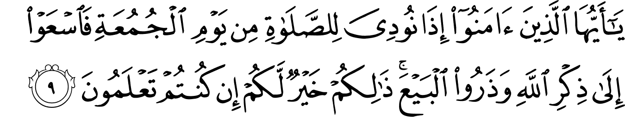
O you who believe! When the call is made for Salaah on the day of Jumu’ah, then hasten to the remembrance of Allah and leave the business. That is better for you if you but knew!
Al-Jumu’ah 62.9
This Ayah stresses the necessity of the remembrance of Allah on Jumu’ah, by attending the Khutbah and the Salaah.

Take Care of your Families, Marriage Ties and Wealth
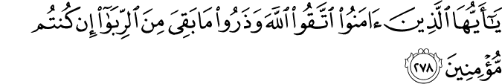
O you who believe! Fear Allah and give up what remains of usury, if you are (indeed) believers. Al-Baqarah 2.278

O you who believe! When you contract with one another any debt for a fixed term, then write it. Let a scribe write it between you, in justice. And a scribe should not refuse to write as Allah has taught him. So let him write and let the one on whom is the right dictate, and let him fear Allah, his Lord, and let him not diminish anything from it. Then if the one on whom is the right, of limited understanding, or weak, or not capable that he can dictate, then let his guardian dictate with justice. And call for evidence two witnesses among your men. And if there are not two men, then one man and two women of whom you agree of as witnesses, so that if she errs, one of the two, then one of the two will remind the other. And the witnesses should not refuse when they are called. And do not be weary that you write it, small or large, for its term. That is more just near Allah and more upright for evidence and nearer that you have no doubt, except that it be a present transaction you carry out amongst you, then there is no sin that you do not write. And take witness when you make a commercial transaction. And the scribe should not be harmed, and not the witness, and if you do, then indeed it is a sinful conduct for you, and fear Allah and Allah teaches you. And Allah, of everything, is All-Knower. Al-Baqarah 2.282
This is the longest Ayah in the Glorious Qur’aan.

O you who believe! Do not consume usury, doubled and multiplied. And fear Allah so that you may be successful.
Ál-‘Imrān 3.130

O you who believe! It is not lawful for you that you inherit the women by force. And constraint them not so that you may take a part of what you have given them, except that they openly commit immorality. And live with them in kindness. But if you dislike them, then perhaps you dislike a thing that Allah has placed much good in it. An-Nisā’ 4.19

O you who believe! Do not consume your wealth between yourselves unjustly, but that there be business on mutual consent among you. And do not kill yourselves. Indeed, Allah is to you Most Merciful. An-Nisā’ 4.29
Allah prohibits His believing servants from illegally acquiring each other’s wealth and property using various dishonest methods such as riba, gambling and other wicked methods.

O you who believe! Take testimony among you when death approaches one of you, at the time of making the will, two just men among you, or two others from other than you, if you are travelling in the earth then befalls you the calamity of death. Detain both of them after Salaah and if you doubt let them both swear by Allah, ‘We will not exchange it for a price even if he is of a near relative, and we will not conceal testimony of Allah. Indeed we will then surely be of the sinners. Al-Mā’idah 5.106

O you who believe! When you marry believing women, and then divorce them before you have touched them, then no waiting period have you to count concerning them. So provide for them and release them with a good release. Al-Ahzāb 33.49 This Ayah contains many rulings, including the use of the word ‘Nikah’ for the marriage contract alone. There is no other Ayah in the Qur’aan that is clearer than this on this point.

O you who believe! When the believing women come to you as emigrants, then examine them. Allah is most knowing of their faith. And if you know them to be believers, then do not return them to the disbelievers. They are not lawful for them, and they (the disbelievers) are not lawful for them. But give them what they have spent. And there is no blame upon you if you marry them when you have given them their (bridal) dues. And do not hold to marriage bonds with disbelieving women, but ask for what you have spent, and let them ask (you) what they have spent. That is the Judgement of Allah. He judges between you. And Allah is All-Knowing, All-Wise. Al-Mumtahanah 60.10
This Ayah indicates that faith (Imaan) can be recognised and affirmed. The believing woman is prohibited from marrying an idolater and the believing man is prohibited from marrying the idolatress.

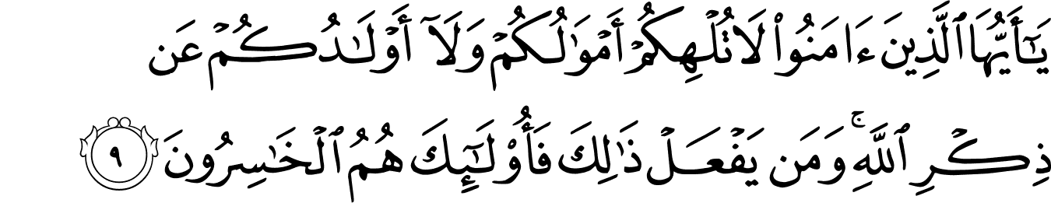
O you who believe! Let not your wealth and nor your children divert you from the remembrance of Allah. And whoever does that, then those are the losers. Al-Munāfiqún 63.9
This Ayah stresses the importance of not being too concerned with the matters of the worldly life. Allah the Exalted orders His faithful servants to remember Him frequently and to refrain from being distracted from His remembrance by indulging in their property and children excessively.

O you who believe! Indeed, from your spouses and your children are enemies for you; so beware of them. But if you pardon and overlook, and forgive, then indeed, Allah is Oft-Forgiving, Most Merciful. At-Taghābun 64.14
This Ayah warns against the trials of the spouses and offspring. Wealth and children are a test and trial from Allah the Exalted so that He knows those who obey Him and those who do not.

O you who believe! Protect yourselves and your families from a Fire whose fuel is people and stones, over it are Angels, stern, severe; they disobey not Allah in what He Commands them, but they do what they are commanded. At-Tahrìm 66.6
This Ayah encourages one to teach one’s family the religion and good behaviour. Abdullah Ibn Abbas Radiallahu Anhu said ‘Work in the obedience of Allah, avoid disobedience of Allah and order your families to remember Allah. Then Allah will save you from the Fire’ – Fire whose fuel is people and stone idols that they worshipped.

Be Mindful of your Sustenance
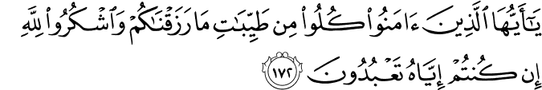
O you who believe! Eat from the good of what We have provided you, and be grateful to Allah, if you (indeed) worship Him alone. Al-Baqarah 2.172
Eating from pure sources is the cause of acceptance of Du’aa and acts of worship, just as eating from impure sources prevents the acceptance of Du’aa and acts of worship.

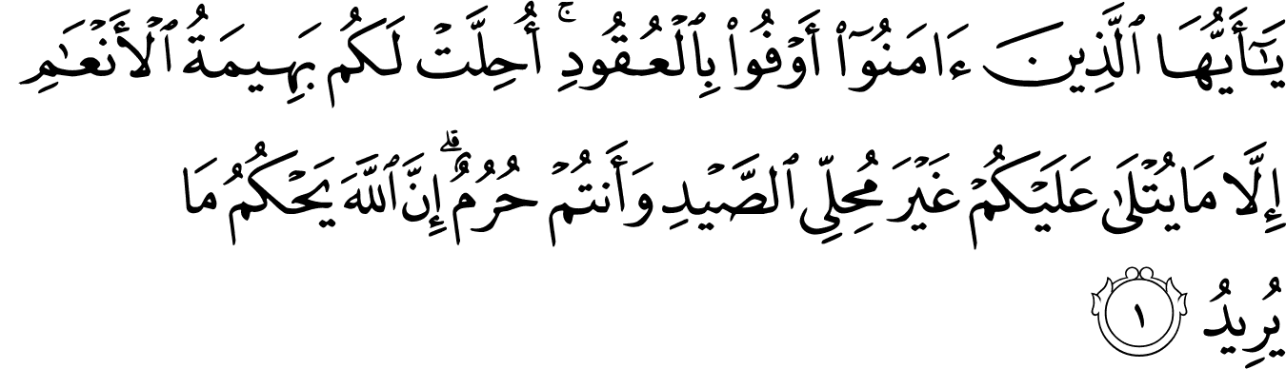
O you who believe! Fulfil the obligations. Made lawful for you are the quadruped of the grazing livestock except what is recited to you, not being permitted to hunt while you are in ihram. Indeed, Allah decrees what He wills. Al-Mā’idah 5.1
Quadruped refers to beasts of cattle – camels, cows, sheep and goats. Lawful is any beast which resembles cattle insofar as it feeds on plants and is not a beast of prey. (Imam Razi)

O you who believe! Do not make unlawful of the good things of what has been made lawful by Allah for you, and do not transgress. Indeed, Allah does not love the transgressors.
Al-Mā’idah 5.87
Do not make it hard for yourselves by prohibiting the permissible things and do not transgress by falling into extravagance.

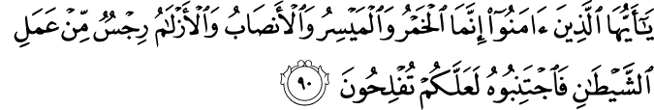
O you who believe! Indeed, the intoxicants and the games of chance and (sacrifices at) altars and divining arrows are an abomination from the work of the shaitaan, so avoid it so that you may be successful. Al-Mā’idah 5.90
Allah prohibited consuming intoxicants and gambling and sacrifices at altars and arrows (azlaam) used for lotteries to make decisions.
Exhibit Good Social Conduct
O you who believe! Do not say ‘listen to us’, but say ‘make us understand’ and listen. And for the disbelievers there is a painful torment. Al-Baqarah 2.104

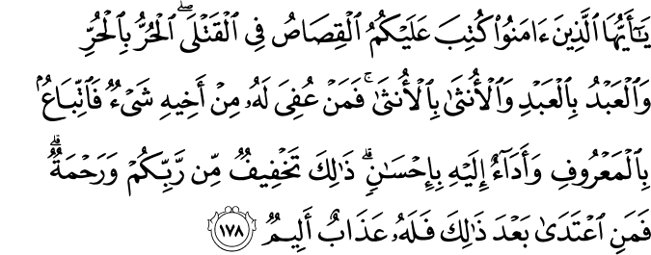
O you who believe! Prescribed for you is the legal retribution (qisās) in the case of the murdered: the freeman for the freeman, the slave for the slave, and the female for the female. But whoever is pardoned for it from his brother anything, then do a suitable follow-up and payment to him with kindness. That is a concession from your Lord and a mercy. Then whoever transgresses after that, then for him is a painful torment.
Al-Baqarah 2.178
Qisās means equality in punishment. All are equal before the Law. ‘Pardoning’ means accepting blood money [diyah] after capital punishment becomes due in cases of intentional murder. Qatadah said this Ummah [Muslims] is allowed to apply the penal code [execution] or to pardon and accept the blood money. The wisdom of the Law of Equality is that the sanctity of life is preserved. This preservation is because the potential killer will refrain from killing, as he will be certain that if he kills, he would be killed.

O you who believe! Do not ask about things if made clear to you, it may distress you, and if you ask about it when the Qur’aan is being revealed, it would be made clear to you. Allah has pardoned about it, and Allah is Oft-Forgiving, All-Forbearing. Al-Mā’idah 5.101
The apparent wording of this Ayah indicates that we are forbidden to ask about things that if one has knowledge of, he would be sorry he had asked. Consequently, it is better to avoid such questions.

O you who believe! Do not follow the footsteps of shaitaan. And whoever follows the footsteps of shaitaan, then indeed, he commands the immorality and the evil. And had it not been for the Grace of Allah and His Mercy on you, not one of you would ever have been pure. But Allah purifies whom He wills, and Allah is All-Hearer, All-Knower. An-Núr 24.21
This Ayah is a warning given in the most concise and eloquent manner. The footsteps of shaitaan refers to his deeds, his evil whispers and all types of sins.

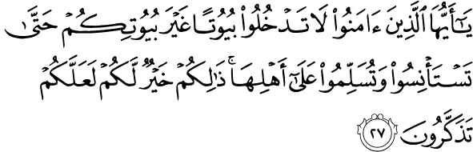
O you who believe! Do not enter the houses other than your own, until you have asked permission and you have greeted its inhabitants. That is best for you, so that you may pay heed.
An-Núr 24.27
This is the Islamic etiquette of entering houses.
O you who believe! Let those whom your right hands possess and those among you who have not attained puberty ask your permission (to present themselves) at three times: before Fajr Salaah, and when you put off your garments at noon (for rest) and after the Isha Salaah. These three are times of privacy for you. There is no blame on you or on them after that, to move about among you, some of you (attending) to others. Thus Allah makes clear for you the Ayaat. And Allah is All-Knower, All-Wise. An-Núr 24.58

O you who believe! Do not be like those who abused Musa; then Allah cleared him of what they said. And he was near Allah, honourable. Al-Ahzāb 33.69
This Ayah is a warning not to abuse the Prophets of Allah.

O you who believe! If a wicked person comes to you with information, investigate, lest you harm a people in ignorance, then you become, over what you have done, regretful.
Al-Hujurāt 49.6
Investigate the reliability of the news conveyed by wicked people. This is why groups of scholars of Hadith refuse to accept narrations from narrators whose reliability is unknown, for in reality, they might be from among the wicked people. Regardless of whether the information is true or not, Allah forbade taking the path of the corrupters and sinners.

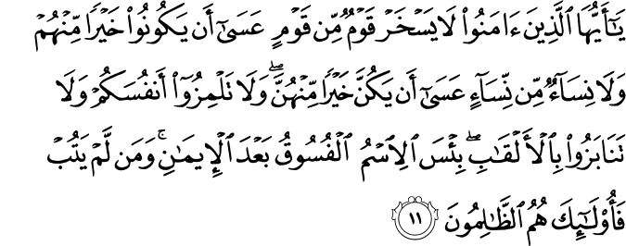
O you who believe! Let not a people ridicule another people; perhaps they may be better than them. And let not women (ridicule) other women, perhaps they may be better than them. And do not insult yourselves (one another) and do not call each other by nicknames. Wretched is the name of disobedience after faith. And whoever does not repent, then those, they are the wrongdoers. Al-Hujurāt 49.11
Do not belittle people, do not defame people, and do not address people by nicknames that they dislike.

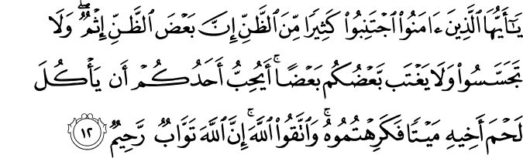
O you who believe! Avoid much of suspicion. Indeed, some suspicion is sin. And do not spy and do not backbite some of you (to) others. Would one of you like to eat the flesh of his dead brother? Nay, you would hate it. And fear Allah. Indeed, Allah is the Oft-Returning, Most Merciful. Al-Hujurāt 49.12
Just as you hate to eat the flesh of a dead person, on account of your good nature, so hate backbiting on account of your religion. Do not spy with ill intentions. Rasulullah Sallallahu Alaihi Wasallam explained that backbiting is mentioning about your brother or sister in a manner that he or she dislikes.

O you who believe! When it is said to you ‘Make room’ in the assemblies, then make room. Allah will make room for you. And when it is said ‘Rise up’, then rise up. Allah will raise those who believe among you and those who were given the knowledge, in degrees. And Allah, of what you do, is All-Aware. Al-Mujādilah 58.11
O you who believe! Why do you say what you do not do?
As-Saff 61.2
Most hateful it is with Allah that you say that which you do not do. As-Saff 61.3
These Ayaat relate to the necessity of fulfilling promises.

Prepare for the Aakhirah
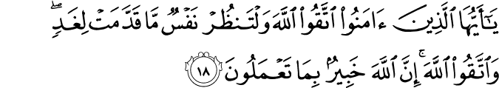
O you who believe! Fear Allah and let every soul look at what it has sent forth for tomorrow, and fear Allah. Indeed, Allah is All-Aware of what you do. Al-Hashr 59.18
Hold yourself accountable before you are held accountable in Aakhirah and recompensed, good for good and bad for bad.

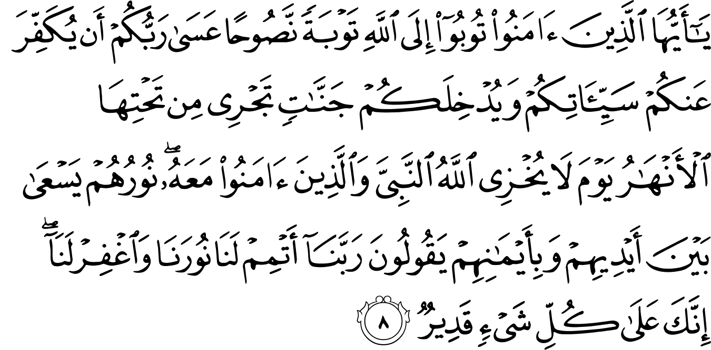
O you who believe! Turn to Allah in repentance, sincerely. Perhaps your Lord will remove from you, your evil deeds and admit you into Gardens; rivers flow from underneath it – the Day that Allah will not disgrace the Prophet and those who believed with him. Their light will run before their hands and on their right; they will say: ‘Our Lord! Perfect for us our light and grant forgiveness to us. Indeed, You are over everything, All-Powerful. At-Tahrim 66.8
This Ayah encourages sincere repentance.

Surahs of the Qur’aan Majeed

Surah Revealed at | Number of Surahs | Percentage of Surahs | Number of Ayaat | Percentage of Ayaat
Makkah | 86 | 75% | 4,613 | 74%
Madina | 28 | 25% | 1,623 | 26%
Total | 114 | 100% | 6,236 | 100%

Approximately three-quarter of the Surahs and three-quarter of the total number of Ayaats were revealed in Makkah. One-quarter of the Surahs and one-quarter of the Ayaats were revealed in Madina. (Even though 21 Surahs may be classified either way, Makki or Madani, the difference is negligible.)

Surah by Number
There are 114 Surahs in the Qur’aan Majeed, 57 odd-numbered Surahs and 57 even-numbered Surahs. They are analysed as follows:
- 27 odd-numbered Surahs have a total number of odd Ayaat.
- 27 even-numbered Surahs have a total number of odd Ayaat.
- 30 odd-numbered Surahs have a total number of even Ayaat.
- 30 even-numbered Surahs have a total number of even Ayaat.

Surah by Ayaat
Surah | Number of Surahs | Percentage of Surahs | Makki | Madani
Surahs ending with odd number of Ayaat | 54 | 47% | 43 | 11
Surahs ending with even number of Ayaat | 60 | 53% | 43 | 17
Total | 114 | 100% | 86 | 28

Surah by Length
Number of Ayaat in Surah | Number of Surahs | Percentage of Surahs | Makki |  | Madani
Number of Ayaat in Surah | Number of Surahs | Percentage of Surahs | No. of Surahs | No. of Pages * | No. of Surahs | No. of Pages *
1 to 10 | 19 | 17% | 16 | 8 | 3 | 2
11 to 49 | 47 | 41% | 32 | 80 | 15 | 66
50 to 99 | 30 | 26% | 25 | 188 | 5 | 60
100 to 199 | 14 | 12% | 11 | 190 | 3 | 99
200 and over | 4 | 4% | 2 | 51 | 2 | 103
Total | 114 | 100% | 86 | 517 (61%) | 28 | 330 (39%)
Notes
* Number of pages is based on the Qur’aan of 847 pages, 13 lines per page.

Nisful Qur’ān – midpoint of the Qur’ān Majeed in terms of letters is in Surah Al-Kahf 18:19. It is in the word وَلْيَتَلَطَّفْ wal-yatalattaf, between the ت tā’ and the ل lām (word translates to ‘courteous but cautious’). The verb's triliteral root is lām ṭā fā (ل ط ف). The word lateef comes from the same root.

‘O You Who Believe!’ Ayaat

Surah No. | Surah | Revealed at | ‘O You Who Believe’ Ayaat | Total
2 | Al-Baqarah | Madina | 104, 153, 172, 178, 183, 208, 254, 264, 267, 278, 282 | 11
3 | Al-‘Imrān | Madina | 100, 102, 118, 130, 149, 156, 200 | 7
4 | An-Nisā’ | Madina | 19, 29, 43, 59, 71, 94, 135, 136, 144 | 9
5 | Al-Mā’idah | Madina | 1, 2, 6, 8, 11, 35, 51, 54, 57, 87, 90, 94, 95, 101, 105, 106 | 16
8 | Al-Anfāl | Madina | 15, 20, 24, 27, 29, 45 | 6
9 | At-Taubah | Madina | 23, 28, 34, 38, 119, 123 | 6
22 | Al-Hajj | Madina | 77 | 1
24 | An-Núr | Madina | 21, 27, 58 | 3
33 | Al-Ahzāb | Madina | 9, 41, 49, 53, 56, 69, 70 | 7
47 | Muhammad | Madina | 7, 33 | 2
49 | Al-Hujurāt | Madina | 1, 2, 6, 11, 12 | 5
57 | Al-Hadìd | Madina | 28 | 1
58 | Al-Mujādilah | Madina | 9, 11, 12 | 3
59 | Al-Hashr | Madina | 18 | 1
60 | Al-Mumtahanah | Madina | 1, 10, 13 | 3
61 | As-Saff | Madina | 2, 10, 14 | 3
62 | Al-Jumu’ah | Madina | 9 | 1
63 | Al-Munāfiqun | Madina | 9 | 1
64 | At-Taghābun | Madina | 14 | 1
66 | At-Tahrìm | Madina | 6, 8 | 2
20 |  |  |  | 89

- Three Surahs begin with the Ayah ‘O you who believe!’ (Al-Mā’idah, Al-Hujurāt and Al-Mumtahanah), three Surahs end with it (Al-‘Imrān, Al-Mumtahanah and As-Saff) and three have the Ayah halfway through the Surah (Al-‘Imrān, Al-Mujādilah and At-Tahrìm).
- The Ayah appears in 20 Surahs, ten even and ten odd-numbered Surahs.
- 44 even-numbered and 44 odd-numbered Ayaat begin with ‘O you who believe’, and one Ayah with this phrase in the middle (33.56).
- All 89 Ayaat appear in Surahs revealed in Madina.
- The Ayah appears most frequently in Surah Al-Mā’idah – 16 times.
- The Ayah appears as the first and last Ayah in Surah Al-Mumtahanah.
- The most time it appears is in Ayah number nine – 4 times.
- The Ayah appears in Surah Al-Hajj as an Ayah of Sajdah.
- Two consecutive Ayaat of ‘O you who believe!’ appears 8 times.
- In these 89 Ayaat, ‘It-taqullah’ - fear Allah - appears 19 times, twice in 2:282 and in 59:18.

‘Ya ayyuha-annāsu’ - ‘O mankind’ Ayaat

Surah No. | Surah | Revealed at | Ya ayyuha-annāsu  ‘O mankind’ Ayaat | Total
2 | Al-Baqarah | Madina | 21, 168 | 2
4 | An-Nisā’ | Madina | 1, 170, 174 | 3
7 | 'A'-raaf | Makkah | 158 | 1
10 | Yunus | Makkah | 23,57,104,108 | 4
22 | Al-Hajj | Madina | 1,5,49,73 | 4
27 | Naml | Makkah | 16 | 1
31 | Luqmaan | Makkah | 33 | 1
35 | Faatir | Makkah | 3,5,15 | 3
49 | Al-Hujurāt | Madina | 13 | 1
9 |  |  |  | 20

- ‘Ya ayyuha-annāsu’ appears in the whole Qur’aan 20 times in 9 Surahs. Of the 20 Ayaat, half of them relate to the belief in Allah, the worship of Him Who created you, and to fear Him as your Lord.
- Two Surahs begin with ‘Ya ayyuha annāsu’ - An-Nisā’ and Al-Hajj.
‘Ya ayyuha-annabiyyu’ – ‘O Prophet’ Ayaat

Surah No. | Surah | Revealed at | Ya ayyuha-annabiyyu  ‘O Prophet’ Ayaat | Total
8 | Al-Anfāl | Madina | 64,65,70 | 3
9 | At-Taubah | Madina | 73 | 1
33 | Al-Ahzāb | Madina | 1,28,45,50,59 | 5
60 | Al-Mumtahanah | Madina | 12 | 1
65 | At-Talāq | Madina | 1 | 1
66 | At-Tahrìm | Madina | 1,9 | 2
6 |  |  |  | 13

- ‘Ya ayyuha-annabiyyu’ appears in the whole Qur’aan 13 times in 6 Surahs.
- 3 Surahs begin with ‘Ya ayyuha-annabiyyu’ - Al-Ahzāb, At-Talāq and At-Tahrìm.
- 2 Ayaat have the same wording, At-Taubah 73 and At-Tahrìm 9.
- 6 Ayaat are related to Jihād and striving in the Path of Allah. 6 Ayaat relate to the wives of the Prophet Sallallahu Alaihi Wasallam and women in general and 1 Ayah states the role of the Messenger of Allah, Sallallahu Alaihi Wasallam.
- 5 of the 13 Ayaat end with Allah is al-Ghafoor and ar-Raheem, Oft-Forgiving, Most Merciful in regards to matters mentioned in those Ayaat.

‘Ya ayyuha-arrasool’ – ‘O Messenger’ Ayaat

Surah No. | Surah | Revealed at | Ya ayyuha-arrasool  ‘O Messenger’ Ayaat | Total
5 | Al-Mā’idah | Madina | 41,67 | 2
23 |  |  | 51 (Ya ayyuha-arrusulu) | 1
2 |  |  |  | 3

‘Ya ayyuha-arrasool’ appears 3 times in the Qur’aan Majeed in 2 Surahs.

‘Ya ahla-al-kitaab’ – ‘O People of the Scripture’ Ayaat

'Surah No. | Surah | Revealed at | Ya ahla-al-kitaab  ‘O People of the Scripture’ Ayaat | Total
3 | Al-‘Imrān | Madina | 64, 65, 70, 71, 98, 99 (Ayaat 98 and 99 begin with Qul) | 6
4 | An-Nisā’ | Madina | 171 | 1
5 | Al-Mā’idah | Madina | 15, 19, 59, 68, 77 (Ayaat 59, 68 and 77 begin with Qul) | 5
3 |  |  |  | 12

There are 12 Ayaat in 3 Surahs addressing the People of the Scripture, that is, the Jews and the Christians.

‘Ya Bani Isra-eel’ – ‘O Children of Isra-eel’ Ayaat

Surah No. | Surah | Revealed at | Ya bani Isra-eel  ‘O Children of Isra-eel’ Ayaat | Total
2 | Al-Baqarah | Madina | 40, 47, 122 (Ayaat 47 and 122 have the same wording) | 3
5 | Al-Mā’idah | Madina | 72 (In the middle of the Ayah) | 1
7 | 'A'-raaf | Makkah | 134 (At the end of the Ayah) | 1
20 | Tahā | Makkah | 80 | 1
61 | As-Saff | Madina | 6 (In the middle of the Ayah) | 1
5 |  |  |  | 7

There are 7 Ayaat in 5 Surahs addressing the Children of Isra-eel. They are the children of Yakub Alaihis Salaam (son of Ishaaq, grandson of Ibrahim Alaihimus Salaam). Yakub Alaihis Salaam had 12 sons, Yahuda, Hadhrat Yusuf Alihis Salaam, Bin Yameen (Judah, Joseph, Benjamin) and 9 others. All of his descendants are called Bani Isra-eel. Bani Isra-eel took their name from Yahuda (Judah), therefore calling themselves Yahudi (Jews). The Ayah addressing the Yahud is in Al-Jumu’ah 62:6:

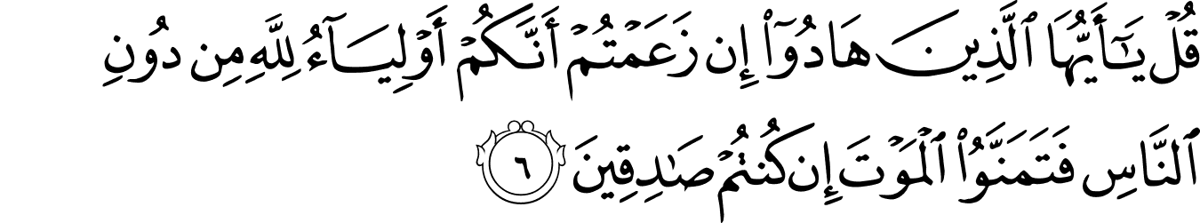
Qul yāayyuhā alladhīna hādū – ‘Say ‘O you who are Jews! If you claim that you are allies of Allah, to the exclusion of other people, then wish for death, if you are truthful.’

NOTES
- Zamakhshari and Imam Razi Rahimahumullah say that this Ayah contextually addresses the Jews and the Christians who do believe in most of the earlier revelations but do not regard the message of the Qur’aan as true. (Message of the Qur’an – Muhammad Asad)
- In Surah Al-Mumtahanah Ayaat 8 and 9 the believers are reminded that friendly relations with unbelievers who are not hostile to the Muslim community are permissible, even desirable.
‘Allah does not forbid you from those who do not fight you in the religion and do not drive you out of your homes that you deal kindly and justly with them. Indeed, Allah loves those who act justly.’
‘Allah only forbids you from those who fight you in the religion and drive you out of your homes and support in your expulsion that you make them allies. And whoever makes them allies, then those are the wrong-doers.’ (Al-Mumtaĥanah 60:8-9)
- The term ‘najas’ (impure) occurs in the Qur’aan only in this one instance and carries a spiritual meaning (immoral, faithless, wicked).
- The people thus addressed are the followers of earlier revelations (Ahl al-Kitaab), and in particular the true Unitarian followers of Isa Alaihis Salaam. (Muhammad Asad)
- Al-Hawāriyyūn (singular hawāri) is the designation applied in the Qur’aan to the disciples of Isa Alaihis Salaam. Hawāri is derived from hawar, meaning whiteness – one who wears white garments, ‘the white garbed ones’. (Muhammad Asad)

