HAJJ

OF

CHANGE

CONTENTS Page

Hajj of Change 5
The Sacred House of Allah Ta’ala and Hajj 7
Methods of Performing Hajj 11
The Mawaaqit 13
The Haram Boundary of Makkah 15
Travel Plans 16
Umrah 17
Ihraam Procedure 18
Entry into al-Masjid al-Haraam 19
How to Perform Tawaaf 22
How to Perform Sa’ee 25
Shaving or Trimming Hair 27
Things Allowed During Ihraam 28
Restrictions During Ihraam 28
Umrah Chart 29
Rules 32
The Hajj 36
Hajj – An Effective Approach 38
Keep Your Enemies in Check 39
The Beginning of Hajj
Mina 41
Arafaat 43
Muzdalifah 46
Mina 10th Dhul Hijjah 48
Mina 11th to 13th Dhul Hijjah 51
Makkah 53
Time Frame for Hajj Rites 54
Rami Times 56
Women in Menstruation 57
Ziyaarah of Madina Munawwarah 60
Finally 65
References 66
Du’aa for Tawaaf and Other Occasions 67

Du’aa to Learn the Rites of Hajj

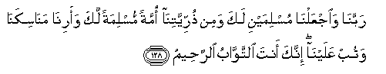

Our Lord!
Make us Muslims, bowing to Your Will,
And of our progeny a people Muslim, bowing to Your Will,
And show us our Manaasik (rules and places of Hajj rites),
And turn unto us (in Mercy);
For You are the Oft-Relenting, Most Merciful!
(Al-Baqarah 128)

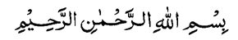


THE HAJJ OF CHANGE

If you perform your Hajj with the sole intention of pleasing Allah Ta’ala, then Allah Ta’ala graces your Hajj with His acceptance, and you will become aware of His acceptance when, within you a deep spiritual transformation takes place, and the Hajj leaves a lasting impression on you. Such is the Hajj of Change! It makes you want to change your lifestyle to one that pleases Allah Ta’ala simply by following His Chosen Way of Life.

To perform such a Hajj is achievable. All you have to do is to correctly and meaningfully perform all the rites of Hajj and wholeheartedly devote your time before and during the days of Hajj in ibaadah (worship) in the best possible manner! Furthermore, bearing in mind the Qur’aan Majeed was revealed in Makkah and Madina, you should not only complete several recitals of it, but also ponder on the meaning of the ayaat therein, and because of the enormous thawaab promised, perform all your Salaah with Jama’ah in Masjid al-Haraam and Masjid an-Nabawi.

For such a Hajj, Allah Ta’ala not only graces it with His acceptance, but grants two more glorious rewards:

- The forgiveness of all your sins.
Rasulullah Sallallahu Alaihi Wasallam said: ‘Whoever performs Hajj for Allah’s pleasure and does not commit any acts of indecency or transgressions, he will return (sinless) just like the day his mother gave birth to him!’ (Sahih al-Bukhari and Sahih Muslim)
According to this Hadith, all your previous sins against the rights of Allah Ta’ala are forgiven (with major sins through Taubah and Istighfaar) and you start off with a clean record!

- The promise of entry into Jannah.
Rasulullah Sallallahu Alaihi Wasallam said: ‘The reward for a Hajj Mabroor (one accepted by Allah Ta’ala) is nothing but Jannah!’ (Sahih al-Bukhari and Sahih Muslim)
According to this Hadith, a Hajj accepted by Allah Ta’ala will result in a spiritual awakening which will keep you away from committing sins in the future, or have the sins forgiven through repentance, thus the reward is nothing but Jannah!

If you are financially and physically capable of going for Hajj, then do not delay any further. No one knows what tomorrow brings! By delaying it without any genuine excuse, you are by your action, denying the fact that Hajj is already Fardh on you. Hajj delayed is Hajj denied!!

Before going for Hajj you should clear all your debts owed to fellow Muslims and friends, seek forgiveness of those whom you may have offended, and use only halaal earnings for the journey. You should learn all the rites and prayers of Hajj and you should endeavour to go with a group given to piety and righteousness. May Allah Ta’ala make it easy for us to perform our Fardh Hajj as soon as possible and grace it with His acceptance, and grant us the opportunity to perform many more Hajj, Aameen!!

Special thanks to Maulana Muhammad Kassim and Maulana Siddiq Ahmad, both of Manchester, England for reviewing and checking through the manuscript, and heartfelt thanks to my parents and all in my family for help, support and advice. May Allah Ta’ala accept this and generously reward us all for our efforts, Aameen!

Compiled and Written by: Rashid Ahmad Diwan

APPROVED BY:
MAULANA BASHIR AHMED DIWAN
8 DUNDEE PLACE
BLOCKHOUSE BAY
AUCKLAND 0600, NEW ZEALAND
RAMADAN 1429 Hijrah (September 2008)

Second Edition, Sixth Print August 2016
THE SACRED HOUSE OF ALLAH TA’ALA AND HAJJ
As the following ayaat show, the answers to the basic questions of where to go for Hajj, why to go, what to do and when to go, have been beautifully preserved in the Holy Qur’aan for eternity.
In Surah Al-Hajj, Allah Ta’ala says that He showed Ibraheem Alaihis Salaam the site where the Holy Ka’bah was to be built:
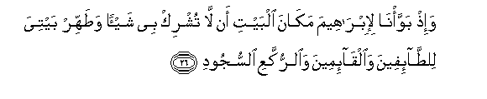
Behold! We pointed the site to Ibraheem (Alaihis Salaam) of the (Sacred) House, (saying) ‘Associate not anything (in worship) with Me; and sanctify My House for those who make Tawaaf of it, or stand up, or bow or prostrate themselves (in Salaah). (Al-Hajj verse 26)

In Surah Al-Baqarah, Allah Ta’ala commanded him to build His Sacred House on that site and in Surah Aal-i Imraan confirmed its construction:
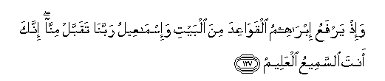
And remember Ibraheem (Alaihis Salaam) and Ismail (Alaihis Salaam) raised the foundations of the House (with the prayer): ‘Our Lord! Accept (this service) from us: for You are the All-Hearing, the All-Knowing. (Al-Baqarah 127)


The first House (of worship) appointed for men was that at Bakka (Makkah): full of blessing and of guidance for all the worlds. (Aal-i Imraan 96)

Once the Sacred House was built, Allah Ta’ala instructed Ibraheem Alaihis Salaam to announce to mankind to come for Hajj:
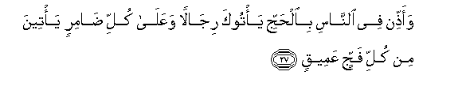
And proclaim the Hajj among mankind: they will come to you on foot and on every lean camel through deep and distant mountain highways. (Al-Hajj 27)

Allah Ta’ala states that Hajj is a duty mankind owe to Him:
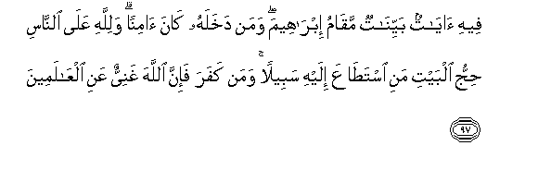
In it are signs manifest; the Station of Ibraheem; whoever enters it attains security; Hajj thereto is a duty men owe to Allah – those who can afford the journey; but if any deny faith, Allah stands not in need of any of His creatures. (Aal-i Imraan 97)

It should be performed only for the sake of Allah Ta’ala:
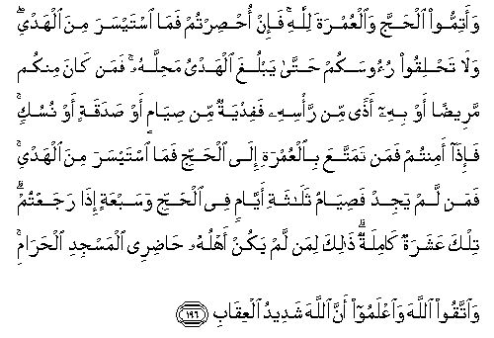
And complete the Hajj and Umrah in the service of Allah… (Al-Baqarah 196)

The rites of Hajj in summary are stated next:

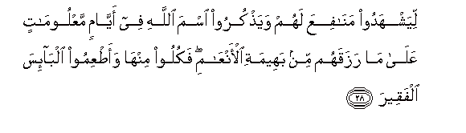

That they may witness the benefits (provided) for them, and celebrate the Name of Allah through the Appointed Days, over the cattle which He has provided for them (for sacrifice): then eat thereof and feed the distressed ones in want.

Then let them complete the rites prescribed for them, fulfil their vows, and perform Tawaaf of the Ancient (liberated from shirk) House. (Al-Hajj 28 and 29)

After specifically mentioning sacrifice in the next few ayaat, Allah Ta’ala states that the sacrifice is not a blood offering, but a test of piety:
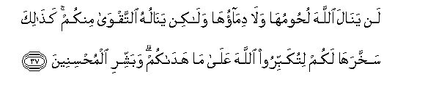
It is neither their meat nor their blood that reaches Allah: it is your Taqwa – piety and righteousness that reaches Him. (Al-Hajj 37)

And it should be performed during the months of Hajj, and without any sinful acts:
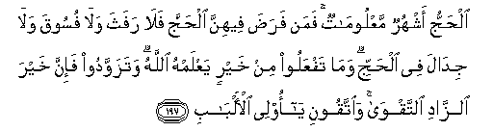
For Hajj are the months well known. If anyone undertakes that duty therein, let there be no rafath (sexual relations and acts leading to it), nor fusuuq (all kinds of ihraam violations), nor jidaal (disputes and arguments) in the Hajj. And whatever good you do (be sure) Allah knows it. And take a provision (with you) for the journey, but the best of provisions is Taqwa - piety and righteousness. So have Taqwa, O you that are wise. (Al-Baqarah 197)

Like all other forms of ibaadah, the purpose of Hajj is to acquire Taqwa. Rasulullah Sallallahu Alaihi Wasallam said: ‘At-Taqwa hahuna, at-Taqwa hahuna, at-Taqwa hahuna’ – pointing to his chest he said Taqwa resides in the heart. The Qur’aan Majeed confirms this in Surah Al-Hajj ayah 32 ‘Thus it is, and whosoever honours the Symbols of Allah, then it is truly from the Taqwa of the hearts (taqwal quloob)’. The word Taqwa literally means to put a partition through ibaadah between you and the ghadhab (anger and punishment) of Allah Ta’ala.

As mentioned in Aal-i Imraan ayah 96, the first House of Allah Ta’ala was built at Makkah Mukarramah and also in Makkah came the last Messenger of Allah Ta’ala. Rasulullah Sallallahu Alaihi Wasallam said that in a long line of Messengers, he was the final Messenger of Allah, similar to him being the final brick placed to complete a palace. Symbolically, Rasulullah Sallallahu Alaihi Wasallam placed the Hajr al-Aswad on the wall at the completion of the reconstruction of the Holy Ka’bah.

The importance of Hajj, the fifth pillar of Islam, can be gauged from the fact that around forty ayaat relating to it are in the Holy Qur’aan (mostly Al-Baqarah 196 to 203, and Al-Hajj 26 to 37), and in Sahih al-Bukhari there are about 350 Ahaadith on it and related matters and in Sahih Muslim over 580 Ahaadith .
METHODS OF PERFORMING HAJJ
There are three methods of performing Hajj, two with, and one without Umrah.
- At-Tamattu - the Umrah is performed first with one Ihraam (ihraam clothes, intention and Talbiyah), then Hajj with another ihraam, with a break in between.
- Al-Qiraan - the Umrah is performed first and then Hajj, with the same ihraam.
- Al-Ifraad - the Hajj is performed alone without the Umrah (normally for residents of al-Haram).

The rules of this Umrah and Hajj are written according to the Hanafi School of Thought (Madhhab). Where there are major differences, the rulings of the Shafi’i, Maaliki and Hanbali Schools of Thought have been noted.

The Differences Between The Three Methods
Action | Tamattu Method | Qiraan Method | Ifraad Method
Actions On Arrival
Assume state of ihraam | At meqaat | At meqaat | At meqaat
Intention | For Umrah | For Umrah and Hajj | For Hajj
Tawaaf for Umrah | Yes | Yes | No
Sa’ee for Umrah | Yes | Yes | No
Welcome Tawaaf (Tawaaf al-Qudoom)* | No | Yes | Yes
Sa’ee for Hajj | None at this stage | Perform Sa’ee (recommended to perform now, if not, after Tawaaf al-Ifaadah) | Perform Sa’ee (perform now or after Tawaaf al-Ifaadah)
Action | Tamattu Method | Qiraan Method | Ifraad Method
Shave or trim hair | Yes | No | No
Take off ihraam clothes | Yes | No | No
Actions From 8th to 13th of Dhul Hijja
Assume ihraam | From wherever you are | Still in ihraam | Still in ihraam
Intention | For Hajj | Still with original intention of Umrah and Hajj | Still with original intention of Hajj
Go to Mina, Arafaat, Muzdalifah and back to Mina to perform Rami of Jamrah Aqabah | Yes | Yes | Yes
Perform sacrifice (hadi)** | Yes | Yes | Optional
Shave or trim hair | Yes | Yes | Yes
Perform Tawaaf al-Ifaadah | Yes | Yes | Yes
Perform Sa’ee for Hajj after Tawaaf al-Ifaadah | Yes | Perform now if not already performed | Perform now if not already performed
Rami of all 3 Jamaraat on 11th, 12th (and 13th) | Yes | Yes | Yes
Perform Tawaaf al-Wida | Yes | Yes | Yes
* For those who come from outside the Haram boundary to perform Qiraan or Ifraad method of Hajj, it is Sunnah for them to perform Tawaaf al-Qudoom.

** This sacrifice is in lieu of being allowed to combine Hajj and Umrah. For those who cannot afford a sacrifice, they have to fast for 3 days during Hajj (by 9th Dhul Hijjah) and 7 days after Hajj.

A person performing Tamattu is called a Mutamatti, Qiraan, a Qaarin, and Ifraad, a Mufrid.

According to the Shafi’i, Maaliki and Hanbali Schools of Thought, under the Qiraan method, only one Sa’ee is required, either after Tawaaf al-Qudoom or Ifaadah, and also the Umrah Tawaaf replaces Tawaaf al-Qudoom.

For Hajj and Umrah purposes, there are two land boundaries, the meqaat (outer boundary) and the Haram (inner boundary).

THE MAWAAQIT
The word meqaat (plural mawaaqit) means ‘the boundary’. In Islamic Law it refers to a border for Hajj and Umrah purposes which should not be crossed by land, sea or by air without being in the state of ihraam.

If you go past the meqaat without the ihraam, then you should go back and assume the ihraam. The meqaat for pilgrims from New Zealand, Australia and Fiji is Qarn Al-Manaazil (as-Sayl). You can be in your ihraam clothes from the last port of call (say, Singapore, Kuala Lumpur) and then make your intention for Hajj or Umrah and recite the Talbiyah at the meqaat boundary while in flight. Jeddah is within the meqaat boundary; therefore it cannot be used for ihraam purposes.

Makkah itself is the Hajj meqaat for those who live in Makkah or are already in Makkah from overseas or anywhere else. The Umrah meqaat for such people is al-Hill, that is, the area outside the Haram boundary. The map and diagram on the next page shows the mawaaqit.

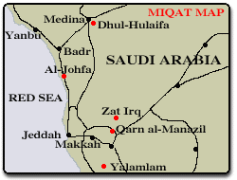

Al-Juhfah (Rabigh)  204km |  |  | Dhul Hulaifah (Abyar Ali)  450km  (for those coming from Madina) |  |  |  | Dhat Irq  94km
 |  |  | MAKKAH |  |  |  | Qarn Al-Manaazil  94km
Yalamlam
94km

THE HARAM BOUNDARY OF MAKKAH
The diagram below shows the Haram, the sacred boundary of Makkah. In the Qur’aan Majeed, Makkah is called ‘Baladan Ameen’ – the City of Peace (At-Teen 3). If you are in Makkah or anywhere within the Haram boundary and you want to perform Umrah, then you will have to go out of the Haram, say, to Masjid of Aa’ishah, and return after adopting the ihraam. While Mina and Muzdalifah are within the Haraam boundary, Arafaat is outside the boundary.

 |  | At-Tan’eem  6km  Masjid of Aa’ishah is here |  |  |  | Nakhlah  14km
Al-Hudaibiyah  15km |  | MAKKAH |  |  |  | Al Ji’ranah  16km
Adah
12km

TRAVEL PLANS
If you are going to Madina before the Hajj, then when you are ready to come to Makkah, you may don the ihraam clothes at Madina and make verbal intention of Hajj and recite Talbiyah at the meqaat of Dhul Hulaifah, of Tamattu, or Qiraan or Ifraad.

If you are going to Makkah first, to perform Umrah, and before the Hajj you plan to go to Madina, then:
- At the meqaat you need to adopt the ihraam for Umrah
- After Umrah, go to Madina, and
- When leaving Madina for Makkah, adopt the ihraam of Ifraad (Hajj only ihraam).

If you are going to Madina after Hajj, then to enter Makkah to perform Umrah and Hajj, you may adopt the ihraam of Tamattu or Qiraan at the meqaat.

Your Hajj will still be valid if when making the intention for Hajj you did not mention the method.

The following is the Tamattu method of Hajj. It has the added advantage of performing Hajj and Umrah separately in the same journey.

UMRAH
The word ‘Umrah’ means ‘the visit’. It can be performed whenever possible during your lifetime (umr in Arabic). In Islamic Law, Umrah means to go in ihraam to Masjid al-Haraam in Makkah to perform Tawaaf of the Holy Ka’bah and Sa’ee between Safa and Marwah.

To perform Umrah once in a lifetime is Sunnah al-Mu’akkadah (emphasised Sunnah). It can be performed anytime of the year, however, according to the Hanafi School of Thought, it is disliked to perform it during the main days of Hajj (9th to 12th of Dhul Hijjah).

According to Shafi’i, and Hanbali Schools of Thought, it is Waajib, and to the Maaliki, it is Sunnah to perform Umrah once in your lifetime and it can be performed at any time of the year.

Rasulullah Sallallahu Alaihi Wasallam said: ‘From one Umrah to the next atones for the sins committed between the two’. (al-Bukhari, Muslim, Ahmad)
Rasulullah Sallallahu Alaihi Wasallam said: ‘An Umrah in the month of Ramadan is equal (in reward) to performing Hajj. (Ibn Majah, Ahmad)

Rasulullah Sallallahu Alaihi Wasallam performed four Umrahs in his lifetime: Umrah of Hudaibiyah, one to make up for the missed Umrah, one from al-Ji’raanah and one he combined with his Farewell Hajj.

The following acts are required for Umrah and they are to be preformed in sequence. If any one is missed, Umrah will not be valid.

- To be in the state of ihraam. This requires three things:
- To put on the ihraam clothes
- To make intention for Umrah, and
- To recite the Talbiyah
- To complete the Tawaaf around the Holy Ka’bah.
- To complete the Sa’ee from Safaa to Marwah.
- To shave or trim the hair of the head.

IHRAAM PROCEDURE – STEP BY STEP
- Before or at the meqaat, if necessary, clean yourself by clipping your nails, trimming your moustache, shaving your armpits and pubic hair.

- Before or at the meqaat, perform wudhu or ghusl.

- Before or at the meqaat, put on the ihraam clothes. The ihraam for men is two pieces of white cloth (known as izaar and ridaa), and nothing else (no caps or undergarments). Wrap one around the waist to cover the legs up to the ankles. Put the second one over your shoulders and drop it around your body. Leave the face and the head uncovered. Footwear should leave the upper part of the feet and ankles uncovered. Women will wear their normal clothes covering their whole body, including the head, leaving only their faces and hands uncovered. This will serve as their ihraam garment. They may wear any shoes. You may scent your body before (not after) ihraam.

- At the meqaat, perform two rak’aat Salaah Sunnah of ihraam.

- At the meqaat, make the intention for Umrah verbally:


Allaahumma inni ureedul Umrata fa yas-sarhu li wa taqabbalhu minni
O Allah! I intend to perform Umrah, so make it easy for me, and accept it from me.

- At the meqaat, recite Talbiyah loudly (women softly):
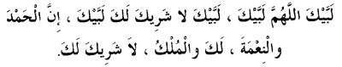
Labbaik. Allahumma labbaik.
Labbaika laa shareeka laka labbaik.
Innal-hamda wan ni’mata laka wal mulk.
Laa shareeka lak.

Here I am. O Allah, here I am.
Here I am, You have no partner, here I am.
Surely all praise, grace and dominion are Yours.
You have no partner.

Recite as often as you can until you reach Masjid al-Haraam to start the Tawaaf. Talbiyah is in response to the Holy Qur’aan ayah 27 in Surah Al-Hajj mentioned before. The state of ihraam begins once you wear the ihraam clothes, utter the intention and recite the Talbiyah. You are now in the state of ihraam. A person in ihraam is called a muhrim.

ENTRY INTO AL-MASJID AL-HARAAM
- Enter the Holy City of Makkah and go to Masjid al-Haraam (Masjid around the Holy Ka’bah, al-Haraam means ‘The Sacred’). Enter the Masjid with the right foot and recite:
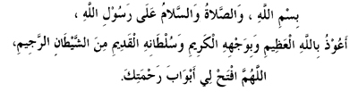
Bismillaahi was-swalaatu was-salaamu 'alaa rasulillaah,
A'udhu billaahil 'adheem, wa biwajhihil kareem, wa sultaanihil qadeem, minash shaitaanir rajeem.
Allaahummaf tahli abwaaba rahmatik

In the name of Allah. Peace and blessing be upon the Messenger of Allah.
I seek refuge in Allah the Great, in His honourable Face and in His Permanent Authority from the accursed shaitaan.
O Allah! Open for me the doors of Your Mercy.

Now make intention for itiqaaf, that is, to stay for any length of time in the Masjid, for ibaadah.
- Now it is the time to see the Holy Ka’bah! During your whole life no matter where you were, you faced the direction of the Holy Ka’bah five times daily in Salaah and now this beautiful and sacred monument of the physical and spiritual centre of the Islamic World is right in front of you! This is a momentous and wonderfully joyous occasion. As soon as you see the Holy Ka’bah, recite:
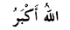 Allahu Akbar 3 times
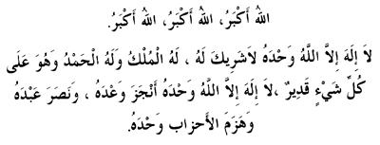 La ilaaha illallaah 3 times

Your Du’aas are readily accepted here. Humbly and earnestly make the following du’aa and any other du’aa to your heart’s content:

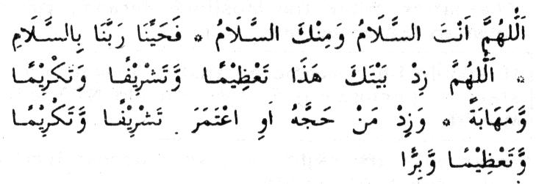
Allaahumma antas salaam, wa minkas salaam, fahayyinaa rabbanaa bis salaam.
Allaahumma zid baitaka hadha ta’ziman wa tashrifan wa takriman wa mahaabatan
Wa zidman hajjahu awi-tamara tashrifan wa takriman wa ta’ziman wa birra.

O Allah, You are as-Salaam, and from You is Salaam and greet us our Lord with Salaam.
O Allah! Increase this House of Yours with reverence, dignity, honour and respect, and increase those who perform Hajj or Umrah towards it in dignity, honour, reverence, obedience and righteousness.
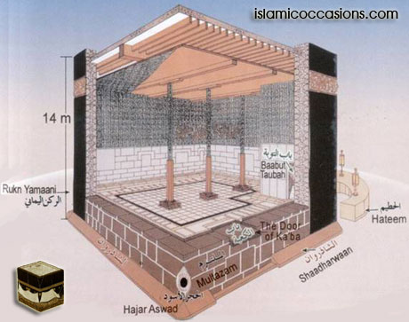
The interior of the Holy Ka’bah - from islamicoccasions.com
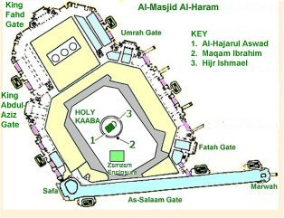The top view of the Masjid al-Haraam - from Ministry of Hajj, Saudi Arabia

HOW TO PERFORM TAWAAF – STEP BY STEP

Make sure your clothes are clean and you are with wudhu. For this Tawaaf of Umrah, men and women should be in their ihraam clothes. The men should leave their right shoulders exposed by bringing the right end of the upper ihraam sheet under the right armpit and throwing it over the left shoulder. This is known as idtiba.

- Stand before the Hajr al-Aswad and make intention to perform Tawaaf of the Holy Ka’bah of a total of seven rounds –
‘I intend to perform Tawaaf of Umrah for Allah Ta’ala’.

- Now raise your hands and say:

Bismillaahi Allaahu Akbar wa-lil Laahil Hamd
In the Name of Allah, Allah is Great, all praise is for Him

- If possible, start by kissing the Hajr al-Aswad (the Black Stone), or touching it with your right hand and then kissing it. Otherwise face the Hajr al-Aswad by standing in line with it (marking may be on the floor of the Tawaaf area). Now stretch your right arm with the hand facing towards the Hajr al-Aswad, and you may then kiss your hand. This is known as istilaam. Istilaam has to be done at the start of all of the seven rounds, and at the completion of the 7th round.

- Start walking around the Holy Ka’bah anticlockwise. For the first three rounds, men should walk briskly and move their shoulders. This is known as ramal. Women should walk normally.

- While walking, make du’aa (any du’aa you wish, in Arabic or in your own language), recite 3rd and 4th Kalimah, make dhikr or recite the Qur’aan Majeed. Act just like you are in Salaah. Only necessary talk is allowed.

- When you reach Rukn al-Yemeni (corner of the Holy Ka’bah facing Yemen, before the Hajr al-Aswad corner), if possible, touch it with your right hand.

- Between Rukn al-Yemeni and the next corner of Hajr al-Aswad, recite this du’aa as often as you can:
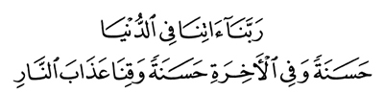
Rabbanaa aatina fid-dunya hasanatau wa fil aakhirati hasanatau wa qinaa a-dhaban naar
O Allah! Give us in this world that which is good and in the Hereafter that which is good, and save us from the torment of the Fire! (Surah Baqarah 201)

- When you reach the Hajr al-Aswad (or the marked line on the floor) one round would be completed. Do the remaining six rounds following the procedure from number 3 to 7.

- After completing the Tawaaf, cover your right shoulder and go to Maqaam Ibraheem. It is a structure on the Tawaaf area close to the Holy Ka’bah which has within it a stone slab with the foot imprints of Hadhrat Ibraheem Alaihis Salaam (Qala inni ja’iluka lil naasi imaamaa – He said: I will make you an Imaam to the people - al-Baqarah 124). On your way there recite:
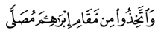
Wat takhi-dhu mim Maqaami Ibraheema musalla
And take the station of Ibraheem Alaihis Salaam as a place of Salaah (Surah Baqarah 125)

- At any place behind it (if possible, otherwise any where in the Haram Shareef), perform two rak’aat Waajib Salaah. You may recite Surah Kaafiroon (complete rejection of kufr) in the first and Surah Ikhlaas (complete acceptance of Tauheed) in the second rak’aah after Surah Faatihah. With this, Alhamdulillah your Tawaaf is now complete!

- If possible, go to Multazam (part of the Holy Ka’bah between Hajr al-Aswad and the Ka’bah door) and make any du’aa you wish. Alternatively, you may do this before performing the Salaah.

- Now go to Zamzam (tanks and taps are all around the Haram) and drink water to your fill, then recite this du’aa:
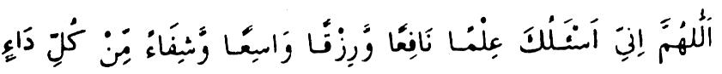
Allaahumma inni as-aluka ‘ilman naafi’an wa rizqan waasi’aan wa shifaa’an min kulli daa’in
O Allah! I ask of You beneficial knowledge, abundant provision and cure from all diseases.

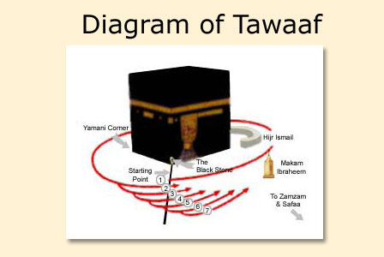
From usahajjguide.com
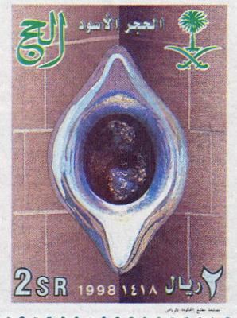
Saudi Arabia postage stamp - Hajr al-Aswad encased in a silver setting

HOW TO PERFORM SA’EE – STEP BY STEP
Still in your ihraam, you now have to perform Sa’ee. This is to walk seven times between Safaa and Marwah (within the Masjid al-Haraam structure). To walk from Safaa to Marwah is counted as one trip and back to Safaa as two trips. Although not a requirement, it is preferable to be with wudhu. If possible, make istilaam of Hajr al-Aswad before you start the Sa’ee.

- When you are about to reach Safaa, recite:
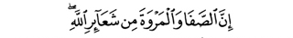
Innas Safaa wal Marwata min Sha’aa-irillah
Indeed Safaa and Marwah are among the signs of Allah
(Surah al- Baqarah 158)

And:

Abda’u bimaa bada’a Allahu bihi
I begin with that which Allah has begun.

- Make intention to perform Sa’ee from Safaa to Marwah of a total of seven trips – ‘I intend to perform Sa’ee of Umrah for Allah Ta’ala’.

- Climb the Safaa hill, face towards the Holy Ka’bah and recite the following three times, and after every recital make any du’aa you wish.
Allahu Akbar, Allahu Akbar, Allahu Akbar
Laa ilaaha illallaahu wahdahu la shareekalahu
Lahul mulku wala hul hamdu, wa huwa 'alaa qulli shay in qadeer.
Laa ilaaha illallaahu wahdahu, anjaza wa'dahu, wa nasara
'abdahu, wa hazamal ahdhaaba wahdahu
Allah is the Great, Allah is the Great, Allah is the Great.
None has the right to be worshipped except
Allah alone, Who has no partner.
To Him belongs the dominion, to Him belongs all praise, and He has power over everything. He fulfilled His promise, gave victory to His servant, and defeated the disbelieving communities Alone.

- Start walking towards Marwah, making du’aa and dhikr. This du’aa may be repeatedly recited:

Rabbigfir warham wa antal a’azzul akram
O Allah! Forgive me and have mercy on me, for you are the Most Mighty and Honourable.

- When you reach the first set of green lights, men should walk briskly until the next set of green lights. This has to be done for all of the seven trips. Women should continue walking normally.

- When you reach Marwah, climb up and turn to face the Holy Ka’bah and follow the du’aa procedure as mentioned in number 3.

- Now walk back to Safaa making du’aa and dhikr. When you reach Safaa, climb up and again follow the du’aa procedure as mentioned in number 3.

- Two trips are now complete. Do the rest in the same manner until you complete seven trips and eight stand-ups for du’aa, ending at Marwah. Alhamdulillah, your Sa’ee is now complete!

SHAVING OR TRIMMING HAIR
Shave your head or trim the hair all round like a normal haircut. Women should cut only an inch of hair from the end of their hair plaits. This releases you from the ihraam restrictions. You may cut your own hair and you may cut someone else’s (if it is the last act of Umrah or Hajj).

Your Umrah is now complete! Alhamdulillaah!! May Allah Ta’ala accept our Umrah, Aameen! All ihraam restrictions are over and you can now wear your normal clothes.

Note: It is Mustahab to perform multiple Umrah, but it is better to perform more Tawaaf.

THINGS ALLOWED DURING IHRAAM
While in ihraam, you are allowed to:
- Wear a watch, eyeglasses, sun glasses, belt pocket, etc.
- Shelter under an umbrella, etc.
- Have a shower for cleanliness or ghusl, if required, with unscented soap.
- Change into a new pair of ihraam.
- Use miswaak or toothbrush with unscented paste.
- Apply unscented kohl (surmah) for sore eyes.
- Kill a crow, kite, scorpion, mouse and vicious dogs, if necessary.

RESTRICTIONS DURING IHRAAM
While in ihraam for Umrah or Hajj, you are not allowed to do the following:
- Have sexual relations with your wife or husband.
- Caress, kiss or hug your wife or husband with desire.
- Men cannot wear any sewn or fitted clothes, such as shirt, trousers, hat, gloves, socks or undergarments. He cannot cover his head or face with anything, whether stitched or not. Women should cover their whole body and head but they cannot cover their faces or wear gloves.
- Men cannot wear shoes but may wear sandals which leave the ankles and upper part of the feet exposed. Women can wear shoes.
- Both men and women cannot cut, trim or shave any hair of their bodies (tafath – superfluous growth of hair and nails).
- Both men and women cannot trim fingernails or toenails.
- Both men and women cannot use perfume, etar or any other perfumed products on their bodies or clothes.
- Fight or quarrel.
- Hunt and kill land game animals.
- Cut plants and trees within the Haram.
- Kill fleas, flies, lice, but no compensation required.
- According to the Hanafi School of Thought, marriage is allowed but consummation of marriage is not. (The Shafi’i, Maaliki and Hanbali Schools of Thought hold that a muhrim cannot marry, nor help others contract marriage, nor get engaged for marriage.)
UMRAH CHART
 |  |  | UMRAH
 |  |  |  |  |  |  |  | Shave/ Trim Hair
Ihraam |  |  | Tawaaf |  |  | Sa’ee
Fardh, Condition and Waajib |  |  | Waajib |  |  | Waajib
Intention for Umrah - Fardh  Recite Talbiyah - Condition  ------------------------Waajib  To wear ihraam clothes from or before the meqaat  To have intention of Umrah from the meqaat |  |  | To cover the body  To clean body with ghusl or wudhu  To perform Tawaaf within the Masjid al-Haraam  To make intention for Tawaaf  Begin Tawaaf from Hajr al-Aswad  Make 7 rounds (4 Fardh + 3 Waajib) starting and finishing at Hajr al-Aswad  Perform Tawaaf anticlockwise  Perform Tawaaf around the Ka’bah including the Hijr/ Hateem (not through it)  Perform Tawaaf walking when you have no excuse  Perform 2 rak’aat Salaah after Tawaaf behind Maqaam Ibraheem |  |  | To cover the body (satr)  Perform Sa’ee only after Tawaaf (not before it)  To make intention for Sa’ee  Begin Sa’ee from Mt. Safaa  Perform Sa’ee walking when you have no excuse  Make 7 trips between Safaa & Marwah
Ihraam  Sunnah |  |  | Tawaaf  Sunnah |  |  | Sa’ee  Sunnah
To have ghusl before putting on ihraam  To perform 2 rak’aat of Salaah for ihraam |  |  | To wear clean clothes  To perform Tawaaf on clean floor  Do ramal – for men to walk briskly in the first 3 rounds  Do idtiba – for men to expose the right shoulder for all 7 rounds  Kiss Hajr al-Aswad, or touch it, or gesture towards it at the start, at the beginning of every round and at the end of Tawaaf  Stop reciting Talbiyah after touching Hajr al-Aswad  To begin with du’aa  Make any du’aa during Tawaaf and finish each round by saying Rabbana ‘aatina…  Perform 7 rounds without unnecessary breaks  After Tawaaf, make du’aa at Multazam  Drink zamzam water |  |  | To perform Sa’ee immediately after Tawaaf (without unnecessary delay)  To be with ghusl and wudhu  To be wearing clean clothes  Face the Ka’bah to say the intention  While climbing upon Safaa & Marwah to say Allahu Akbar thrice & recite 4th Kalimah  Do khabab – for men to run in the green zone  Do wuqoof – to stand upon Safaa and Marwah to make du’aa  Make du’aa upon Safaa and Marwah 4 times each  Perform 7 trips without unnecessary breaks
Ihraam  Mustahab |  |  | Tawaaf  Mustahab |  |  | Sa’ee  Mustahab
Trim nails, moustache, shave armpit & pubic hair before ihraam  To recite Talbiyah loudly  To recite Talbiyah after every Salaah  To recite Talbiyah thrice whenever it is recited |  |  | To touch Rukn Yemeni in every round  To recite Surah Kaafiroon and Ikhlaas in Salaah after Tawaaf  Perform Tawaaf with humbleness  To talk only when necessary  Not to harm anyone with words or action  To make dhikr and du’aa as often as you can |  |  | To kiss the Hajr al-Aswad before starting the Sa’ee  Perform Sa’ee with humbleness  Not to harm anyone with words or action  To make dhikr, du’aa, recite the Qur’aan Majeed while walking

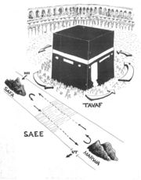
Tawaaf and Sa’ee (from Hajj website)
RULES
Meqaat Rules for Umrah
Rules Violation | Waajib Compensation
If at the meqaat:  - You did not put on the ihraam clothes  - You did not make intention for Umrah  - You did not recite the Talbiyah | Before starting any act of Umrah, go back to the meqaat, otherwise put on the ihraam clothes and sacrifice a sheep or goat, or 1/7th share of a camel or cow  Go back to the meqaat, otherwise make intention before you start Umrah and sacrifice a sheep or goat  Recite Talbiyah and sacrifice a sheep or goat

Waajibaat and Other Rules of Tawaaf and Sa’ee
- If any one or more of the Waajibaat of Tawaaf or Sa’ee is missed, your Tawaaf or Sa’ee will still be valid. However, for any error you will have to either sacrifice a sheep or goat within the Haram boundary, or you will have to repeat the Tawaaf or the Sa’ee.
Furthermore, since the Sa’ee can only be performed after a valid Tawaaf, you will have to repeat the Sa’ee as well, for errors committed in Tawaaf.
Since a Qaarin (one who combines Umrah and Haj) has two ihraams, it is Waajib for him to offer two compensations for an error in ihraam.

- If any of the Sunnah is missed, your Tawaaf and Sa’ee performed will be valid, but the reward will be reduced.

- If any of the Mustahab is missed, there will be no consequences for it.

- You are allowed to break your Tawaaf and Sa’ee for Fardh Salaah with Jama’ah, then resume from where you left off. You are also allowed to break your Tawaaf and Sa’ee to answer the call of nature, or to rest briefly, then resume from where you left off.

Tawaaf Rules
The following compensations apply if you perform Tawaaf without wudhu or ghusl

Tawaaf | Umrah  Tawaaf | Tawaaf al-Qudoom | Tawaaf al-Ifaadah | Tawaaf al-Wida
Performed without Wudhu | Sacrifice a sheep or goat | Give sadaqah for every round (shawt) of Tawaaf | Repeat Tawaaf or sacrifice a sheep or goat | Give sadaqah for every round of Tawaaf
Performed when not with ghusl or when menstruating | Sacrifice a sheep or goat | Sacrifice a sheep or goat | Sacrifice a whole camel or a cow | Sacrifice a sheep or goat

Ihraam Rules
The following compensations apply whether the violations are done in ignorance, forgetfully or knowingly. The ihraam violations apply to both, Umrah and Hajj.

Ihraam Violation | Waajib Compensation
If you had sexual relation with your wife or husband  - During Hajj – anytime before the end of the Day of Arafah  - During Hajj - between the end of the Day of Arafah and shaving/trimming of head hair  - During Hajj – after shaving/trimming  - Touch or kiss your wife or husband with desire at anytime during Hajj | Hajj will become invalid for both. Complete the Hajj (it will now be regarded as Umrah), sacrifice a sheep each and repeat the Hajj next year  Hajj is still valid, but sacrifice a camel  Sacrifice a sheep or goat  Sacrifice a sheep or goat
If you (men) wear a sewn garment, or cover the head, or wear shoes, or women cover the face:  - for less than a day  - for a complete day or more | Give sadaqah*  Sacrifice a sheep, or feed 6 poor persons or fast for 3 days
If you (men) shave or trim your hair:  - less than quarter of your head  - quarter or more of your head | Give sadaqah  Sacrifice a sheep, or feed 6 poor persons or fast for 3 days
If you (men and women) trim your nails:  - less than 5 nails between hands and feet  Ihraam Violation  - more than 5 nails | Give sadaqah of ½ saa’ for each nail clipped  Waajib Compensation  Sacrifice a sheep, or feed 6 poor persons or fast for 3 days
If you (men or women) apply perfume:  - to less than a limb  - to an entire limb or more, or to apply repeatedly | Give sadaqah  Sacrifice a sheep, or feed 6 poor persons or fast for 3 days
If due to some genuine reason you wore sewn clothes (because of high fever, severe cold, etc), or applied perfume, or shaved your hair due to an ailment in your scalp, or removed a nail due to injury | You will still have to either:  Sacrifice a sheep or a goat, or feed 6 poor persons a meal each, or fast for 3 days  (Refer Al-Baqarah 196)

* This sadaqah is the same as sadaqatul fitr, and it is about 3.2 kg (one saa’) of barley or dates or raisins (or 1.66 kg of wheat – ½ saa’) or equivalent cash (in year 2008 currently at NZ$8.00 per sadaqah). The sadaqah can be given there or back at home. The fasting can also be done there or at home.

The sacrifice can only be done there, within the Haram boundary, so if you need to, organise it for the days of Nahr (10th to 12th of Dhul Hijjah) or any other time. If you miss out, get someone to do it for you during the next trip.

The sacrificial meat (Waajib compensation) and the sadaqah should only be given to the poor.

There is no time limit for the sacrifice, sadaqah or the fasting, but the sooner the better. If a Waajib compensation is not done, at the end of your Umrah or Hajj you will be out of your ihraam restrictions, but your Umrah or Hajj will remain defective.
THE HAJJ
The word Hajj means ‘the destination’. In Islamic Law, Hajj means to go to the city of Makkah in the state of ihraam to perform specific acts during the days of Hajj. It is a spiritual retreat like no other!

Hajj is the fifth pillar of Islam. To perform Hajj once in a lifetime is Fardh (compulsory) on every mature male and female (with accompanying mahram – close Shar’ee relative) who is able to physically and financially make the journey.

If you are financially able to perform Hajj, but physically you are too weak or too old to make the journey, you can appoint someone else to perform the Hajj on your behalf.

THE FARAAIDH AND WAAJIBAAT OF HAJJ

The Faraaidh of Hajj are:
- You must be in the state of full ihraam (intention, ihraam clothes, Talbiyah) from the time of intention for Hajj to the time of shaving or trimming the hair on the 10th of Dhul Hijjah (first tahallul), and in partial state of ihraam (ihraam clothes not required) until the performance of Tawaaf al-Ifaadah (second tahallul).

- You must be at Arafaat any time from midday (zawaal) of the 9th to the dawn (subh saadiq) of the 10th of Dhul Hijjah. This is known as Wuqoof al-Arafaat.

- You must perform Tawaaf al-Ifaadah (az-Ziyaarah) any time from the dawn of the 10th to the sunset of the 12th, with intention.

Furthermore, you must:
- Maintain the sequence of ihraam, Wuqoof al-Arafaat and Tawaaf al-Ifaadah.

- Avoid sexual relations before Wuqoof al-Arafaat.

The Waajibaat of Hajj are:
- You should be at Muzdalifah any time from the break of dawn of the 10th to sunrise.
- You should perform rami on the 10th, 11th and 12th, and if you are still in Mina, on the 13th.
- You should sacrifice a sheep or a goat (for Tamattu and Qiraan method of Hajj).
- You should perform Sa’ee after Tawaaf al-Ifaadah.
- You should shave or trim the hair of the head.
- You should perform Tawaaf al-Wida (Farewell Tawaaf), except for menstruating women and residents of Makkah, who are exempted.

The main difference between the Hanafi School of Thought and the Shafi’i, Maaliki and Hanbali Schools of Thought is the inclusion of Sa’ee and Halq/Qasr (shave/trim hair) among the Faraaidh of Hajj.

Rules
If any Faraaidh of Hajj is omitted for any reason, your Hajj will not be valid. You will have to perform it again next year.

If any Waajibaat of Hajj is omitted without a valid reason (forgetfully or knowingly), compensation in the form of a sacrifice of a sheep or goat is compulsory for each Waajib missed. You are also required to make Taubah and seek forgiveness from Allah Ta’ala. If omitted with a valid Shar’ee reason (reason acceptable by Islamic Law, in case of leaving Muzdalifah early, or menstruating women not performing Tawaaf al-Wida), compensation is waived. If necessary, check with your scholars.

If you think you may not be able to complete your Hajj due to illness or some other valid reason, then make your intention with the proper stipulation (ishtirat). If you are prevented from completing your Hajj, sacrifice a sheep or goat, and come out of ihraam. Refer to Surah Al-Baqarah ayah 196.

HAJJ – AN EFFECTIVE APPROACH
Just imagine for a moment that you have left this world. You have just said your farewells, paid off your debts and sought forgiveness of those whom you offended. You are now in a two piece white shroud and you are neither able to enjoy yourself, nor are you at all able to groom yourself, nor exert yourself over anyone! You are now leaving the busy and bustling city and going to an uninhabited place. You will spend some time there getting ready to meet your Lord.

Next day at Arafah, with hundreds of thousands of others, after waiting for half the day, you meet your Lord. He, the Almighty Allah, your Creator and Sustainer, has come down to the lowest heaven to meet you and to judge you. This occasion, the long wait under the hot sun with a multitude of others, and then your audience with your Lord, resembles the Day of Judgement. You must try your utmost, humbly and with great humility, beseech Him to pardon and forgive you and grant you Jannah. You must make a firm promise to Him to live the rest of your life in accordance with His Commands. Give it your hundred percent, in time and effort. At the end of the day, still in your shroud, you move to a resting place.

Once you have rested, you start off your new life by glorifying Allah Ta’ala, accepting His authority over you, and rejecting the devious ploys of the shaitaan, your biggest enemy, by pelting him with stones.

Your next biggest enemy is the love of wealth (hubb-ud-dunya). You make a firm resolve to spend your wealth in the Path of Allah Ta’ala by sacrificing the most important thing, the life of another living creature. You, with your own hands, with the permission of Allah Ta’ala put a fully grown living creature under the knife, and see it lose its life!

Next you go to the barber. Your crowning glory, your desire for beauty and appeal, which you have never completely taken off, you now do that with pleasure. This, your desire (hawaa), your enemy number three, is subjugated.

Now you take off your shroud and go back to the busy and bustling city where arrogance and false ego (nafs) reigns supreme. It is time to conquer this enemy. Humbly, amongst a multitude of people, you walk around the House of Allah, praising, pleading and praying to Him, and symbolically kissing a lifeless stone. O Allah, a stone, a black stone is better than me if I do not follow Your Commands!

You have subjugated your four main enemies and you are now ready to face them in real life. Finally, the Du’aa. O Allah! Forgive all my sins; make me sinless, just like I was the day I was born. O Allah! Accept my appearance in Your truly Supreme Court, and when I finally do meet You, then out of Your Mercy, please grant me Your Jannah, Aameen!!

KEEP YOUR ENEMIES IN CHECK!
Shaitaan
In the Qur’aan Majeed Allah Ta’ala says that we should not follow ‘khutuwatish shaitaan’ – the footsteps of shaitaan (the rival to Adam Alaihis Salaam for superiority in the sight of Allah Ta’ala, hence our open, avowed and perpetual enemy) in:
- purity of faith – Aqaaid and ibaadaat (‘Enter into Islam wholeheartedly’ [2:208]),
- our physical sustenance, therefore our spiritual wellbeing (‘Eat of what is on earth, lawful and good’ [2:168], ‘Eat what Allah has provided for you’ [6:142]) and
- morality - akhlaaq (‘Shaitaan will command what is farshah and munkar – shameful and wrong’ [24:21]).
When Adam Alaihis Salaam was tricked by shaitaan, he took the blame and said
‘Our Lord! We have wronged our own souls (Rabbanaa Dhalamnaa Anfusanaa…7:23).
In contrast to this, when iblees (shaitaan) was asked why he did not obey the Command of Allah Ta’ala to bow down to Adam Alaihis Salaam, he attributed his own arrogance, rebellion and jealousy to Allah Ta’ala by replying ‘Bima Agwaitani’ – you put me in the wrong, that is, misguided me! (7:16 and 15:39).
We pelt each Jamrah (shaitaan) with seven pebbles and in the Qur’aan Majeed iblees’s refusal to bow down to Adam Alaihis Salaam is noted seven times (2:34, 7:11, 15:31, 17:61, 18:50, 20:116 and 38:74) and for the rejecters of the Commands of Allah Ta’ala, there is Hell with seven gates (15:44)!
Hubb-ud-dunya –Love of Wealth
The acquisition of wealth is not evil. It can aid you in attaining the love of Allah Ta’ala through ibaadah and charity. What is evil is hubb-ud-dunya, the love of wealth to the extent that dunya takes precedent over Deen (religion) and you show a lack of concern for the Aakhirah. The Qur’aan Majeed states:
‘Nothing is the life of this world but play and amusement…’ (Al-An’aam 32)
‘It was the life of this world that deceived them…’ (6:130)
‘Nay but you love the fleeting life’ (75:20)

Hawaa
Hawaa is natural desires created in man to secure his existence. Here it refers to what exceeds the limit and becomes impure and evil desires. Hawaa literally means ‘fell down’. It is so called because it throws down its follower.
‘But as for him who feared standing before his Lord and restrained himself from al-hawaa (impure desires and lusts). Verily al-Jannah will be his abode’ (Surah an-Nazi’aat 40 and 41)

Nafs
Nafs means self or psyche. Here it means ego, false ego (false sense of your own value and importance) which makes one commit evil in order to be assured of his future existence at the expense of others. In the Qur’aan Majeed it is referred to as nafs–i-ammaara (the commanding self).
‘Yet I do not absolve myself (of blame); the nafs ammaara certainly incites evil, unless My Lord do bestow His Mercy: but surely My Lord is oft-Forgiving, Most Merciful (Yusuf 53).

Rasulullah Sallallahu Alaihi Wasallam said after returning from a battle, ‘We now return from the small struggle (Jihaad Asghar) to the big struggle (Jihaad Akbar).’ The Sahabah enquired, ‘Oh Rasulullah, what is the big struggle?’ He replied, ‘The struggle against the nafs.’

Nafs-i-ammaara has seven evils which must be eliminated: false pride (takabbur), greed (hirs), jealousy (hasad), lust (shahwat), backbiting (gheebat), stinginess (bukhl) and malice (keena).

THE BEGINNING OF HAJJ

Mina – 8th of Dhul Hijjah

On the 8th of Dhul Hijjah, put on your ihraam clothes from wherever you are in Makkah, express the intention for Hajj verbally, recite the Talbiyah, and leave Makkah anytime in the morning and go to Mina. If it is the day of Jumu’ah, then it is better to leave for Mina after performing Jumu’ah at Masjid al-Haraam.

Intention for Hajj:

Allaahumma inni ureedul Hajja fa yassarhu li wa taqabbalhu minni
O Allah! I intend to perform Hajj, so make it easy for me, and accept it from me.

Stay in Mina and perform Dhuhr and Asr of the 8th, and Maghrib, Isha and Fajr of the 9th. Offer Sunnah and Witr as well. (Note that Islamic date starts from Maghrib and ends at Maghrib the next day). Keep yourself busy reciting the Qur’aan Majeed, making Dhikr, Darood, Istighfaar, Du’aa and reciting the Talbiyah.

Recite Takbiraat-i-Tashreeq after every Fardh Salaah from Fajr of the 9th until the Asr of the 13th inclusive:
Allahu Akbar Allahu Akbar, La Ilaaha Illallahu Wallahu Akbar, Allahu Akbar Walillahil Hamd.

After Fajr leave anytime in the morning and go to Arafaat.

Note that each area is marked by large billboards.

Action in Mina  8th of Dhul Hijjah | Waajib Compensation
Ihraam  Make intention for Hajj (Fardh)  To be in the state of ihraam – in ihraam clothes (Waajib) and to recite Talbiyah (Condition) | Without intention, you Hajj will not be valid  If you are not in ihraam clothes and did not recite Talbiyah, you will have to sacrifice a sheep or goat or 1/7th of a camel or cow
Waajib (Necessary)  There are no Waajib acts related to Hajj to be performed on this day | Not Applicable
Sunnah (Tradition)  - To put on the ihraam from wherever you are in Makkah (you do not have to go out of the Haram boundary)  - Leave Makkah after sunrise of the 8th and go to Mina  - Stay in Mina performing Dhuhr and Asr Salaah of the 8th, and Maghrib, Isha and Fajr Salaah of the 9th  - To spend the night in Mina  - Leave for Arafaat anytime after sunrise | None  (This is highly emphasised. There is great reward for you in following the Sunnah (path, tareeq) of our beloved Rasulullah Sallallahu Alaihi Wasallam. Deliberate neglect of any Sunnah is sinful)
Mustahab (Desirable)  - To recite Talbiyah frequently  - Make Dhikr, Darood, Du’aa, and recite the Holy Qur’aan while in Mina  - Offer Nafl Salaah | None  (This is desirable and adds thawaab and value to your Hajj)
Arafaat – 9th of Dhul Hijjah
Stay in Arafaat until sunset, performing Dhuhr and Asr of the 9th together, during Dhuhr time. Now get ready to perform Wuqoof al-Arafaat. Wuqoof literally means ‘to stand’. Here it means to spend time in Arafah in ibaadah.

Rasulullah Sallallahu Alaihi Wasallam said ‘Hajj is Arafah’, meaning that to spend time at Arafah in worship and devotion is the most important part of Hajj.

Be physically and mentally present in any part of Arafah, whether standing, sitting or riding. Since you have already made intention for Hajj, it is not necessary to make a separate intention to stay at Arafah.

It is better to be with wudhu, stand and face the Qiblah and occupy yourself in Talbiyah, Istighfaar, Dhikr, Darood, recitation of the Holy Qur’aan and Du’aa. Take books of Du’aa extracted from the Holy Qur’aan and Ahaadith with you, such as, Al-Hisn al-Haseen (The Impregnable Fortress) by Muhammad al-Jazri Rahimahullah, Al-Hizb al-A’zam (The Great Prayer Book) by Mulla Ali Qaari Rahimahullah, Munaajaat-e-Maqbool (The Accepted Whispers) by Maulana Ashraf Ali Thanwi Rahimahullah, a booklet of 40 Rabbanaa, etc. If possible, listen to the Khutbah at Namira Masjid.

This, the standing at Arafaat in a sea of humanity, is the most important part of Hajj, similar to the scenario of the Day of Judgement, when the whole of mankind will be standing before Allah Ta’ala waiting to be favourably judged. Do not stay idle nor indulge in unnecessary talks and discussions. You have travelled thousands of kilometres and spend thousands of dollars to get to this place for this day to fulfil the duty you owe to Allah Ta’ala. It is a chance of a lifetime to gain the pleasure and forgiveness of Allah Ta’ala!

Leave for Muzdalifah after sunset. Be patient! This may take a long time as several million pilgrims try to leave Arafah and reach Muzdalifah at the same time!

Note: Do not stay in the valley of Urnah because it is not part of Arafah, but a part of Al-Haram.
Action in Arafaat  9th of Dhul Hijjah | Waajib Compensation
Fardh  To be in the state of ihraam (Intention, Ihraam clothes and Talbiyah)  To stay at Arafaat any time from mid-day of the 9th to dawn of the 10th of Dhul Hijjah (Al-Baqarah 198) | If you are not in ihraam clothes, you will have to sacrifice a sheep or goat.  If you are not there any time during this period, you would have missed your Hajj! It will now be considered as an Umrah. Do your Hajj again next year (next available opportunity).
Waajib  If you choose to stay the daytime, then you must stay there until after the sun sets. This is the Sunnah and the best method.  If you choose to spend the night, then there is no specific time period. | If you leave Arafah before sunset, you will have to sacrifice a sheep or a goat.
Sunnah  - To perform Dhuhr and Asr Fardh Salaah together at Dhuhr time with the Imaam, both shortened to 2 rak’aats each. *  - For the Imaam to deliver 2 Khutubaat  - Not to keep fast | None  (This is highly emphasised. There is great reward for you in following the Sunnah of our beloved Rasulullah Sallallahu Alaihi Wasallam)
Mustahab  - To stop at Namira for ghusl or wudhu  - To recite Talbiyah, Takbeer, Tahleel on your way to Arafah  Action in Arafaat  - To enter Arafah after mid-day  - To be with wudhu for the Wuqoof  - To verbally form intention to stay in Arafah  - To physically stand and face the Qiblah  - To recite the 4th kalimah frequently (best du’aa of the Messengers of Allah Ta’ala) at Arafah  - After sunset, leave for Muzdalifah. | Waajib Compensation  None  (This is desirable and adds value to your Hajj)

* If you are praying alone, you may pray Dhuhr and Asr separately (Imaam Abu Hanifah Rahimahullah) or combine them (Imaam Abu Yusuf Rahimahullah and Imaam Muhammad Rahimahullah).

Note: There is no Jumu’ah Salaah at Arafaat even if it is the day of Jumu’ah.

Muzdalifah – Night of 10th Dhul Hijjah
Stay at Muzdalifah until sunrise of the 10th, and perform Maghrib and Isha together after arriving there. Combine the two Salaah whether performing individually or in Jama’ah. After both Fardh Salaah, perform Sunnah and Witr. You may spend the night or part of the night in ibaadah. Perform Fajr Salaah at dawn then go to Mash’ar al-Haram which is part of Muzdalifah (or stay in any part of Muzdalifah) and make Dhikr and Du’aa there until just before sunrise. This stay is known as Wuqoof al-Muzdalifah and any length of time is sufficient to fulfil its’ Waajib status. Just before sunrise leave for Mina.
You may use a blanket to cover yourself but do not cover your head or face.

Action in Muzdalifah  10th of Dhul Hijjah | Waajib Compensation
Waajib  To be in ihraam  To be present at Muzdalifah any time from the dawn (starting time of Fajr) of the 10th to sunrise | If you are not in ihraam clothes, you will have to sacrifice a sheep or goat.  If you fail to do so, you will have to sacrifice a sheep or goat
Sunnah  - To perform Maghrib and Isha together on arrival with Isha shortened to 2 rak’aats.  - To spend the night in Muzdalifah  - To perform Fajr of the 10th at Muzdalifah  - To then go to al-Mash’ar al-Haram in Muzdalifah and spend time there in Dhikr and Du’aa until just before sunrise (2:198)  - Then to leave for Mina  - To hurry through the valley of Muhassir | None  (This is highly emphasised. There is great reward for you in following the Sunnah of our beloved Rasulullah Sallallahu Alaihi Wasallam)
Action in Muzdalifah  10th of Dhul Hijjah | Waajib Compensation
Mustahab  - To spend the night in Ibaadah  - To recite Talbiyah on your way to Muzdalifah  - To pick pebbles from Muzdalifah or Mina (49 pebbles if you are staying till the 12th or 70 pebbles if you are staying till the 13th) | None  (This is desirable and adds value to your Hajj)
Note  Women, the sick and the weak are allowed to leave Muzdalifah after midnight and go to Mina in order to avoid the rush of large crowds | No penalty

Note: The valley of Muhassir is between Mina and Muzdalifah. It is not part of Muzdalifah or al-Haram. This is where the Ashaab al-Feel incident took place.

Note: It is Waajib to delay Maghrib and Isha Salaah until you reach Muzdalifah.

Mina – Day of 10th Dhul Hijjah
There are four Wajibaat to be performed, if possible, on this day. They are Rami (pelting with pebbles) Nahr (sacrifice), Halq or Qasr (shaving or trimming hair) and Tawaaf al-Ifaadah (az-Ziyaarah). Be patient! Do not rush to complete the rites.
Today you have to perform the Rami of the largest pillar only, Jamrah al-Aqabah, before midday (zawaal). As long as the pebbles hit or fall near the Jamrah, Rami will be in order. There is no Du’aa after pelting Jamrah al-Aqabah. One who is genuinely too ill or too weak may ask someone else to throw the pebbles on his or her behalf. Now intend and perform your Hajj sacrifice, or after ascertaining from reliable sources that your sacrifice has been done, only then shave your head or trim the hair like a normal haircut. You can now wear your normal clothes and you are released from the restrictions of the ihraam (known as the first tahallul), except for sexual relations. You are only released from this restriction after Tawaaf al-Ifaadah.
After the haircut, leave for Makkah and perform Tawaaf al-Ifaadah (with ramal) and Sa’ee. (Perform Tawaaf with idtiba if you are still in your ihraam clothes and have not had a haircut). Unless you have a genuine excuse, you must walk while performing Tawaaf al-Ifaadah. Come back to Mina and spend the night there.
Note: If your Hajj package is such that you will stay in Makkah for 15 days or more before the Hajj begins on the 8th Dhul Hijjah, then you become a muqeem (not a musaafir/traveller). Hence in addition to your Hajj sacrifice, you will be required to perform the annual Eid-ul Adha sacrifice. This is Waajib and it may be done there or arranged back home. There is no Eid Salaat to be performed here.

Action in Mina  10th of Dhul Hijjah | Waajib Compensation
Fardh  To perform Tawaaf al-Ifaadah (with intention) (22:29) | If you do not perform Tawaaf al-Ifaadah, your Hajj will not be valid. Do your Hajj again next year!
Waajib  To be in ihraam | If you are not in ihraam clothes, you will have to sacrifice a sheep or goat.
Action in Mina  10th of Dhul Hijjah | Waajib Compensation
Waajib  To perform Rami - throw seven pebbles at the Jamrah al-Aqabah *  To offer sacrifice (for Hajj Tamattu or Qiraan) –  ‘Whoever holds in honour the Sha’aair of Allah (in the sacrifice of animals), such (honour) should come truly from piety of heart.’ (Al-Hajj ayah 32)  Ibraheem Alaihis Salaam’s sacrifice is mentioned in As-Saaffaat 37:100-109  To shave or trim the hair all around the head. It is also Waajib for a bald person to pass a razor over the head (Al-Fatah 48:27)  To perform Sa’ee after Tawaaf al-Ifaadah  To maintain the sequence of rami, sacrifice, shaving and then Tawaaf al-Ifaadah with Sa’ee** | If you fail to throw the pebbles, or you delay it beyond the dawn of 11th, you will have to sacrifice a sheep or goat  If you do not have the means to sacrifice, then fast 3 days during the days of Hajj and 7 days on returning home. If you did not fast or offer sacrifice then compensation sacrifice will become necessary  If you fail to shave or trim your hair, you will have to sacrifice a sheep or goat  If you do not perform Sa’ee you will have to sacrifice a sheep or goat  If you do not observe the proper sequence, you will have to sacrifice a sheep or goat
Sunnah  - Between sunrise and midday of the 10th, throw 7 pebbles at Jamrah al-Aqabah  - To throw pebbles one by one. If all 7 pebbles are thrown together, they will be counted as only one pebble.  - To stand with the Ka’bah on the left and Mina on the right while throwing the pebbles.  - To stop saying Talbiyah when you begin throwing the pebbles | None  (This is highly emphasised. There is great reward for you in following the Sunnah of our beloved Rasulullah Sallallahu Alaihi Wasallam)
Mustahab  - To throw pebbles the size of a pea  - To throw the pebbles holding between thumb and index finger of the right hand  - To say Allahu Akbar each time you throw a pebble  - To trim the nail and moustache after shaving/trimming the hair (tafath) | None  (This is desirable and adds value to your Hajj)
Other Schools of Thought
According to the Hanbali School of Thought, it is compulsory to make intention to perform Tawaaf al-Ifaadah.

According to the Shafi’i and Hanbali Schools of Thought, the observance of the sequence of Rami, Nahr, Halq and Tawaaf is Sunnah (Maaliki hold it as Waajib).

According to the Shafi’i School of Thought, sacrifice can be done until sunset of the 13^{th.}

* If less than half the number of pebbles are thrown for any one day, you will have to give sadaqah of one saa’ (3.2kg of barley or 1.66kg of wheat, etc.) for each pebble not thrown.

** Due to a valid reason you may perform Tawaaf al-Ifaadah before the other three Waajibaat. The sequence of the first three is Waajib, and the sequence between these and Tawaaf al-Ifaadah is Sunnah.

Mina – 11th to 13th of Dhul Hijjah
Spend the nights of the 11th and the 12th at Mina. On both days perform Rami after zawaal (midday). Spend your days and nights in Mina in Dhikr, Istighfaar, Du’aa and Qur’aan Tilaawat. Spend your time fruitfully in ibaadah and perform all your Fardh Salaah with Jama’ah and offer Witr and Sunnah Salaah. Once you have completed the Rami of the 12th, you may leave for Makkah by sunset. If you have not left by dawn of the 13th, you will have to stay at Mina until the day of the 13th, perform Rami and then leave for Makkah. (Al-Baqarah 203)

Action in Mina  11th to 13th of Dhul Hijjah | Waajib Compensation
Waajib  To perform Rami - throw the pebbles at all 3 Jamaraat | If you fail to perform Rami, you will have to sacrifice a sheep or goat. If you miss one Jamrah, offer sadaqah (for each pebble not thrown)
Sunnah  To spend the night of the 11th and the 12th at Mina –  ‘Remember Allah during the Appointed Days (11, 12 & 13th)…’ (Al-Baqarah 203).  Make Du’aa – Rabbanaa aatina fid-dunya hasana…(Al-Baqarah 201)  To throw 7 pebbles at all 3 Jamaraat between midday and sunset of 11th, 12th (and 13th if you are still in Mina)  To maintain the sequence of throwing the pebbles – smallest, middle and then the large Jamrah  To return to Makkah from Mina before the sunset of the 12th if you are staying only 2 nights (but although Makrooh, allowed until before dawn of 13th) | None  (This is highly emphasised. There is great reward for you in following the Sunnah of our beloved Rasulullah Sallallahu Alaihi Wasallam)
Mustahab  After throwing the pebbles at the 1st and 2nd Jamaraat (not the 3rd), to face the Qiblah and make Du’aa | None  (This is desirable and adds value to your Hajj)
Other Schools of Thought
According to the Shafi’i, Maaliki and Hanbali Schools of Thought, it is Waajib to stay the nights of the 11th, 12th (and 13th if still in Mina) at Mina .

According to the Shafi’i, Maaliki and Hanbali Schools of Thought, it is Waajib to maintain the sequence in throwing pebbles at the Jamaraat – small to large.

According to the Shafi’i, Maaliki and Hanbali Schools of Thought, you must return to Makkah before the sunset of the 12th (if you are staying only 2 nights)

Note: According to some scholars, Jumu’ah Salaah may be performed at Mina if it is the day of Jumu’ah. However, there is no Jumu’ah Salaah for a musaafir (traveller).

Makkah – The Final Stay
While in Makkah you may perform as many Nafl Tawaaf as you want. Before leaving for home, you will have to perform Tawaaf al-Wida as the last act at Masjid Al-Haraam. There is no Sa’ee to be performed with this Tawaaf.

With the performance of Tawaaf al-Wida, your Hajj is now complete! Alhamdulillah! May Allah Ta’ala accept your Hajj and our Hajj as Hajj Mabroor and may the spiritual experience change your life for the better and the benefits and blessings of Hajj be with you for a very long time!! May this Hajj create in you a desire to go for Hajj every so often, every five years or so, as the following Hadith of Rasulullah Sallallahu Alaihi Wasallam states.

In a Hadith Qudsi Rasulullah Sallallahu Alaihi Wasallam reported that Allah Ta’ala said: ‘Verily a servant, whom I gave a healthy body, and I expanded for him his livelihood, and five years pass upon him that he does not come to Me (for Hajj), then he is deprived’. (Ibn Hibbaan and Al-Bayhaqi)

Action in Makkah | Waajib Compensation
Waajib  To perform Tawaaf al-Wida from any time after Tawaaf al-Ifaadah. There is no ending time. | If you do not perform Tawaaf al-Wida, you will have to sacrifice a sheep or goat.  Menstruating and childbirth bleeding women are exempted. (However, every effort should be made to delay your departure.)

TIME FRAME FOR HAJJ RITES
(Using Islamic Day and Night – Maghrib to Maghrib)

The table below shows the earliest and the latest times of the Hajj rites and the compensation required if any of the rites is not performed within the given time.

Action | Earliest Time Allowed for Action to be Valid | Latest Time Allowed Without Requiring  Compensation | If Missed During This Time
Rami of 10th Dhul Hijjah | Dawn of 10th  (See Rami table for detail) | Dawn of 11th  (See Rami table for detail) | Sacrifice a sheep or goat
Rami of 11th Dhul Hijjah | Midday (zawaal) of 11th | Dawn of 12th | Perform qadha rami with the 12th and sacrifice a sheep or goat*
Rami of 12th Dhul Hijjah | Midday (zawaal) of 12th | Dawn of 13th | Perform qadha rami with the 13th and sacrifice a sheep or goat
Rami of 13th Dhul Hijjah | Sunrise of 13th ** | Sunset of 13th  (See Rami table) | The time for rami is now over. You will have to sacrifice a sheep or goat
Nahr - sacrifice – Within the Haram boundary # | Dawn of 10th | Sunset of 12th | Sacrifice a sheep or goat as compensation
Action | Earliest Time Allowed for Action to be Valid | Latest Time Allowed Without Requiring  Compensation | If Missed During This Time
Halq / Qasr – shaving / trimming hair within Haram boundary | Dawn of 10th | Sunset of 12th | Sacrifice a sheep or goat
Tawaaf al-Ifaadah (az-Ziyaarah) | Sunrise of 10th | Sunset of 12th | Perform as soon as possible and also sacrifice a sheep or goat
Return to Makkah from Mina | Midday (zawaal) of 12th | Before dawn of 14th | No compensation
Tawaaf al-Wida | Dawn of 10th | No time limit | If not performed, then sacrifice a sheep or goat

* If Rami is missed out for one day or more than one day, only one sacrifice of a sheep or goat will be required.

** Zawaal of 13th according to the other Schools of Thought

# Preferably in Mina. If sacrificed outside the Haram boundary, you will have to sacrifice a sheep or goat as compensation.

RAMI TIMES
The table below shows the possible times for Rami from the 10th to the 13th of Dhul Hijjah.

Action | From  Dawn  to Sunrise | Sunrise  to Midday (zawaal) | Midday (zawaal)  to Sunset | After Sunset to Dawn the Next Day
10th Dhul Hijjah  Rami of Jamrah Aqabah | Makrooh (allowed but not desirable) * | Sunnah | Mubah (Allowed) | Makrooh (allowed but not desirable) *
11th of Dhul Hijjah  Rami of all 3 Jamaraat | Not allowed # | Not allowed # | Sunnah | Makrooh (allowed but not desirable)*
12th of Dhul Hijjah  Rami of all 3 Jamaraat | Not allowed # | Not allowed # | Sunnah | Makrooh (allowed but not desirable)*
13th Dhul Hijjah  Rami of all 3 Jamaraat | Not allowed # | Makrooh -allowed but not desirable | Sunnah | Not allowed

* It is allowed (not Makrooh) for the women, children, the sick and the weak, and those with a genuine excuse. Without a genuine excuse, a sacrifice of a sheep or goat will be required. According to some scholars, it is also allowed for women to perform Rami before the dawn of the 10th, if necessary.

# If done, then do it again in the afternoon, otherwise sacrifice a sheep or goat.
WOMEN IN MENSTRUATION
Two Basic Rules
- Whether you are menstruating or not, you cannot enter Makkah for Umrah or Hajj without assuming ihraam.
- You cannot enter Masjid al-Haraam to perform Tawaaf or Salaah when you are menstruating.

If You Start Menstruating | What Should You Do | Compensation
Before or at the meqaat | Have a bath and assume ihraam at the meqaat (wear proper clothes, make intention and recite Talbiyah) and enter Makkah | If you enter Makkah without ihraam, you will have to sacrifice a sheep or goat.
While in Makkah before Umrah | While in Makkah, you remain in ihraam. When you stop menstruating, do ghusl and perform Umrah. | If in ignorance you perform Umrah while you are menstruating, you will have to sacrifice a sheep or goat.
During Umrah Tawaaf | Stop and come out of the Masjid al-Haraam. When you stop menstruating, do ghusl and perform Tawaaf. | No compensation required
During Umrah Sa’ee | Finish Sa’ee and complete Umrah. Your Umrah is valid. | No compensation required
On your way back to Makkah from Madina | Assume ihraam at Dhul Hulaifah (near Madina) and proceed to Makkah | If you enter Makkah without ihraam, you will have to sacrifice a sheep or goat.
If You Start Menstruating | What Should You Do | Compensation
On 8th Dhul Hijjah – when Hajj begins | Assume ihraam for Hajj; go to Mina, Arafaat, and Muzdalifah, back to Mina, performing rami, sacrifice, and haircut except entering Masjid al-Haraam to perform Tawaaf al-Ifaadah.  When you stop menstruating, do ghusl, and then perform Tawaaf al-Ifaadah. | If out of ignorance you perform Tawaaf al-Ifaadah while you are menstruating or childbirth bleeding, your Tawaaf will be valid but you will have to sacrifice a whole camel or a cow.  Although the time for Tawaaf al-Ifaadah ends at sunset of the 12th, there is no compensation required even if you perform it late due to menstruation.
Anytime during Hajj | Continue to be in ihraam and perform all the rites of Hajj except Tawaaf al-Ifaadah as mentioned above. | As per above
Anytime before Tawaaf al-Ifaadah on 10th Dhul Hijjah | If you fear you will begin to menstruate, you are allowed to perform the Tawaaf before rami, sacrifice and trimming the hair.# | No compensation required
At the time of performing Tawaaf al-Wida | You are excused from it.  However, try your best to delay your departure. | No compensation required

# Tawaaf al-Ifaadah is compulsory. If you do not perform it, your Hajj will not be valid.

If your menstruation days are many (up to 10 days) and in no way you can delay your departure to your home country, then after padding yourself properly you may perform Tawaaf al-Ifaadah and compensate for this by sacrificing a whole camel or a cow.

According to some scholars, if there is no harm, you may use medicine to delay your menstruation in order to perform Tawaaf al-Ifaadah. Sa’id bin Mansur reported that Ibn Umar Radhiallahu Anhu was asked about a woman who takes some medicine to delay her menstruation. Ibn Umar Radhiallahu Anhu replied he saw no harm in it. (Fiqh-us-Sunnah)
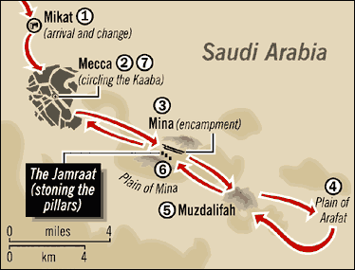
The Hajj Journey

ZIYAARAH OF MADINA MUNAWWARAH
It is Sunnah to go to Madina Munawwarah with the intention of visiting and offering Salaah in Masjid an-Nabawi and it is the consensus of the four Schools of Thought that it is Mustahab, that is, highly desirable to visit the Sacred Grave of Rasulullah Sallallahu Alaihi Wasallam. It is the greatest of all Mustahab acts. On your way to Madina, and during your stay there, recite Darood Shareef as often as possible.

As mentioned before, enter the Masjid of Rasulullah Sallallahu Alaihi Wasallam with your right foot and recite the Du’aa and make intention for i’tiqaaf. Perform two rak’aat Tahiyatul Masjid, if possible, in the area between the Sacred Grave and the Mimbar (pulpit), known as the Raudhah. Rasulullah Sallallahu Alaihi Wasallam said: ‘Between my home (Sacred Grave) and my Mimbar is a garden from the gardens of Jannah’.
Go to the Sacred Grave with utmost respect, much reverence and humility. You are standing in front of the last of the Messengers of Allah Ta’ala, on whom the last of the Books of Allah Ta’ala, the Holy Qur’aan, was revealed. You are in his Ummah and you are a follower of his Sunnah. his path, his tareeq. You recite Salaam and Darood on him in each and every Salaah every day, and you give shahaadah, bear witness that he is the Messenger of Allah Ta’ala in every Salaah, just like the Muaddhin bears witness in every Adhaan. You will need his Shafaa’ah, his intercession to Allah Ta’ala to pardon you on the Day of Judgement! In front of the Sacred Grave, first recite Darood Shareef:
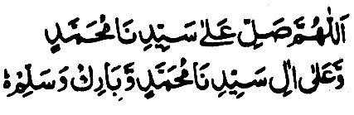

Allaahumma swalli aala Sayyidina Muhammadiu wa ‘alaa aali Sayyidina Muhammadiu wa baarik wa sallim
Now recite the Salaam:

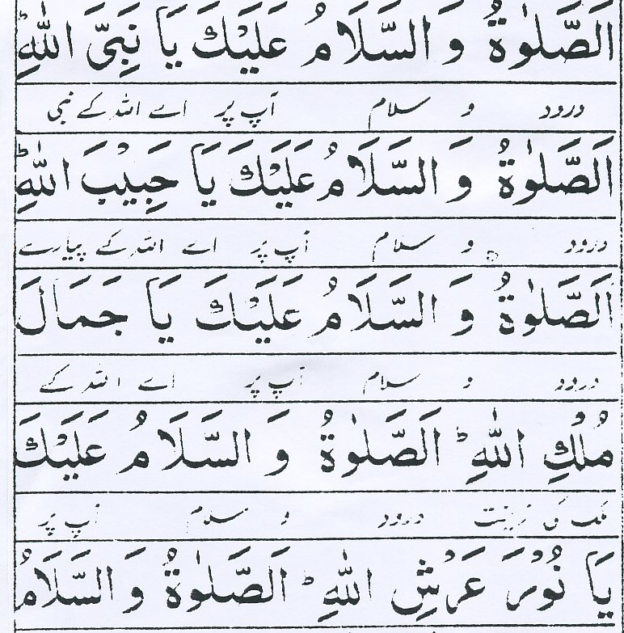

As-salaatu was-salaamu ‘alaika yaa Nabiyallaah
As-salaatu was-salaamu ‘alaika yaa Habiballaah
As-salaatu was-salaamu ‘alaika yaa Jamaala Mulkillaah
As-salaatu was-salaamu ‘alaika yaa Nura ‘Arshillaah
As-salaatu was-salaamu ‘alaika yaa Khaira Khaqqillaah

Darood and Peace be on you, O Messenger of Allah
Darood and Peace be on you, O the beloved one of Allah
Darood and Peace be on you, O the greatest beauty of Allah
Darood and Peace be on you, O the Light of the Arsh of Allah
Darood and Peace be on you, O the best of the creation of Allah

Ash-hadu allaa ilaaha illal lahu wa ash-hadu anna Muhammadan abduhu wa Rasuluh
I bear witness that there is no god but Allah, and I bear witness that Muhammad (Sallallahu Alaihi Wasallam) is His servant and Messenger.

We humbly request you to please offer our heartfelt Salaams at the Holy Grave of Rasulullah Sallallahu Alaihi Wasallam.

Now move to the right and offer Salaam to Hadhrat Abu Bakr Radhiallahu Anhu:

Assalaamu ‘alaika yaa Khalifata Rasulallaah
Assalaamu ‘alaika yaa sayyidanaa Aba Bakri-nis Siddiq Radhiallahu Anhu

Now move further right and offer Salaam to Hadhrat Umar Farook Radhiallahu Anhu:

Assalaamu ‘alaika yaa Ameerul Mu’mineen
Assalaamu ‘alaika yaa ‘Umarab-nal Khattaab Radhiallahu Anhu

After Salaam, make Du’aa to Allah Ta’ala. As long as you stay in Madina, do the Salaam routine daily.
If possible, make as much Salaah and ibaadah at the Raudhah as you can and as often as you can. If possible, stay in Madina Tayyiba for eight days and perform 40 Fardh Salaat with Jama’ah in the Masjid. Each Salaah is better than a thousand Salaah in any other place except Masjid al-Haraam. Spend most of your time in the Masjid, reciting the Qur’aan Majeed, making dhikr and du’aa, and reciting Darood Shareef in abundance.

Before leaving Madina, perform two rak’aat nafl Salaah in the Masjid, then offer Salaam to Rasulullah Sallallahu Alaihi Wasallam.

Places to Visit
- It is Sunnah to visit Masjid-i-Quba and offer Salaah in it. This is the first Masjid built by Rasulullah Sallallahu Alaihi Wasallam. To offer two rak’aat of nafl here is equal in reward to one Umrah.

- Visit Masjid Qiblatain and offer Salaah in it. This is the place where the Qiblah was changed from Baitul Maqdis to the Holy Ka’bah during Salaah.

- It is Sunnah to visit the cemetery of Jannatul Baqee to offer Salaam and Du’aa. Here are the holy graves of the family of Rasulullah Sallallahu Alaihi Wasallam and of the Sahabah.

- It is Sunnah to visit the cemetery of Uhud to offer Salaam and Du’aa. This is where the Battle of Uhud took place. The graves of Hadhrat Hamza Radhiallahu Anhu, the uncle of Rasulullah Sallallahu Alaihi Wasallam, and of other Sahaabah are here. Bless them with Salaam and Du’aa.

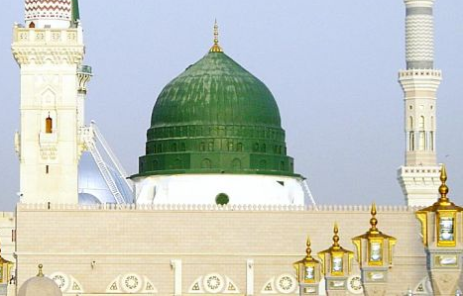
Al-Masjid an-Nabawi, Madina

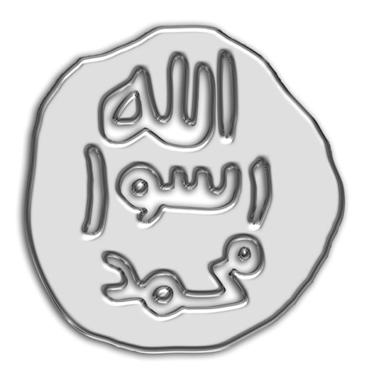

The Seal of Rasulullah Sallallahu Alaihi Wasallam

FINALLY
Now that you have accomplished the fifth and final pillar of Islam, promise yourself what Allah Ta’ala asked you to do:
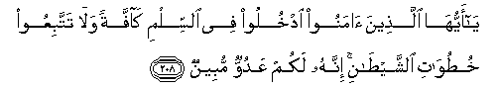
O you who believe! Enter into Islam wholeheartedly; and follow not the footsteps of shaitaan; for he is to you an avowed enemy. (Al-Baqarah 208)

You will perform your Salaah five times daily with devotion, fast during the days of Ramadan and give your Zakaah fully every year. You will make Islah (reformation) among your family members and Muslim neighbours, and Da’wah (propagation) among your non-Muslim friends. You will recite the Holy Qur’aan daily with understanding and practice, and spend time gaining deeper Islamic knowledge. You will stay away from all major sins, especially the ones peculiar to Western countries, such as, Haraam earnings, dealing in interest, all forms of intoxicants and unrestricted mingling of sexes. Finally, you will keep in check your four worst enemies, shaitaan, hubb-ud dunya (love of wealth), nafs (false ego) and hawaa (lowly desires).

May Allah Ta’ala accept yours and our Hajj and make it a catalyst for change! Aameen!

We humbly request all our dear brothers and sisters going for Hajj or Umrah, while you are in Masjid al-Haraam at Makkah Mukarramah and Masjid an-Nabawi at Madina Munawwarah, and during Hajj, especially at Arafaat, please include us and our families in your Du’aa for Allah Ta’ala to forgive our errors, and to grant us all that is good in this world and all that is good in the hereafter and save us from the punishment of the Fire, Aameen!

RABBANAA TAQABBAL MINNA INNAKA ANTAS SAMI ‘UL ‘ALEEM.

REFERENCES
Tafseer Ibn Katheer, by Imaam Ibn Katheer Rahimahullah

Ma’arif-ul Qur’aan, by Mufti Muhammad Shafi Rahimahullah

The Holy Qur’aan, English Translation of the Meanings and Commentary by Abdullah Yusuf Ali

Sahih al-Bukhari, by Imaam Muhammad ibn Ismail al-Bukhari Rahimahullah

Mishkaat al-Masabih, by Ibn Abd Allah Al-Tabrizi Rahimahullah

Al-Quduri (Mukhtasar ), by Imaam al-Quduri Rahimahullah

Virtues of Hajj, by Maulana Muhammad Zakariyya Rahimahullah

Fiqh-us-Sunnah, by Sayyid Saabiq

Fataawa Raheemiyyah, by Mufti Abdur Raheem Rahimahullah

Talim-ul Haq, by Maulana Shabbir Ahmad Desai

Tuhfatul Ikhwaan, by Maulana Muhammad Ibrahim Bakathah

Hajj and Umrah Jurisprudence by Ariss Computer Inc.

How to Perform Hajj, by Dini Book Depot

Minhaj Al-Muslim, by Sheikh Abu Jabir Al-Jaza’iry

Hajj, Umrah and Ziyaarah, by Shaikh Abdul Aziz bin Abdullah bin Baz Rahimahullah

A Guide to Hajj, Umrah and Visiting the Prophet’s Mosque, by Shaikh Muhammad bin Saleh al-Uthaimin

Hajj Guide, by Maulana Mansoor Nomani Rahimahullah

Hajj and Umrah, by Abu Ameenah Bilal Philips

Getting The Best Out of Hajj, by Abu Muneer Ismail Davids

Du’aa For Tawaaf and Other Occasions
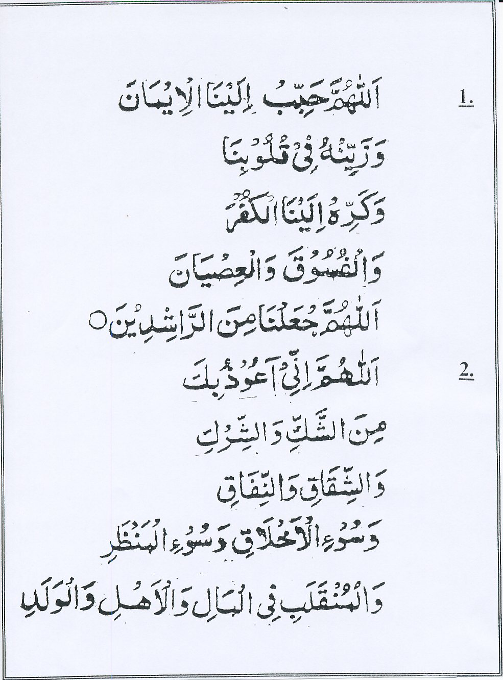
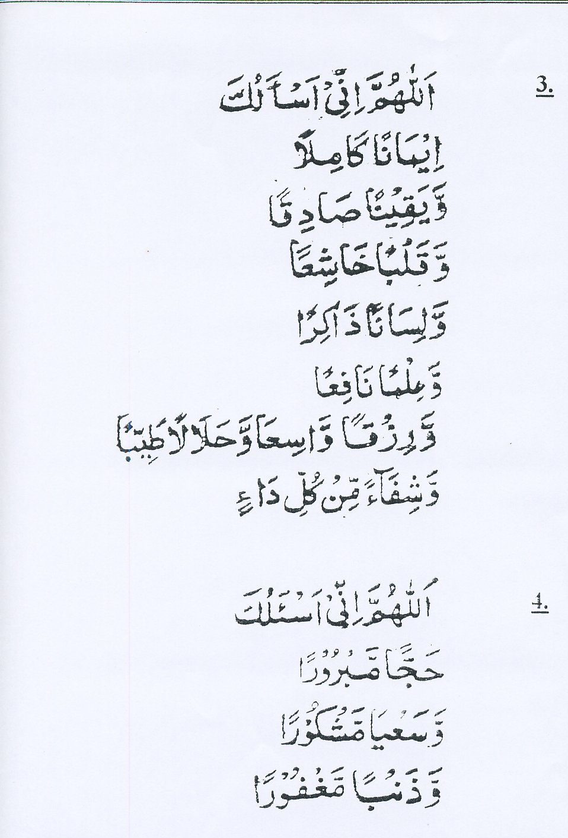
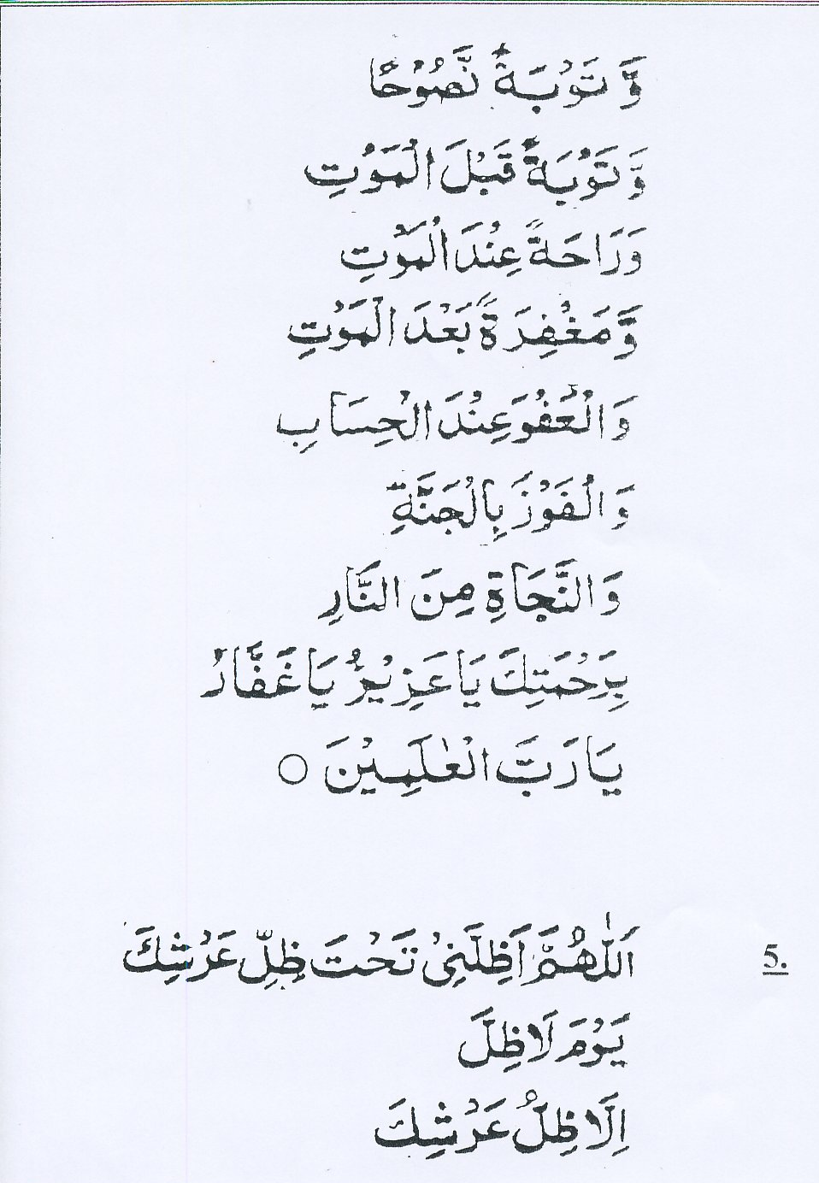
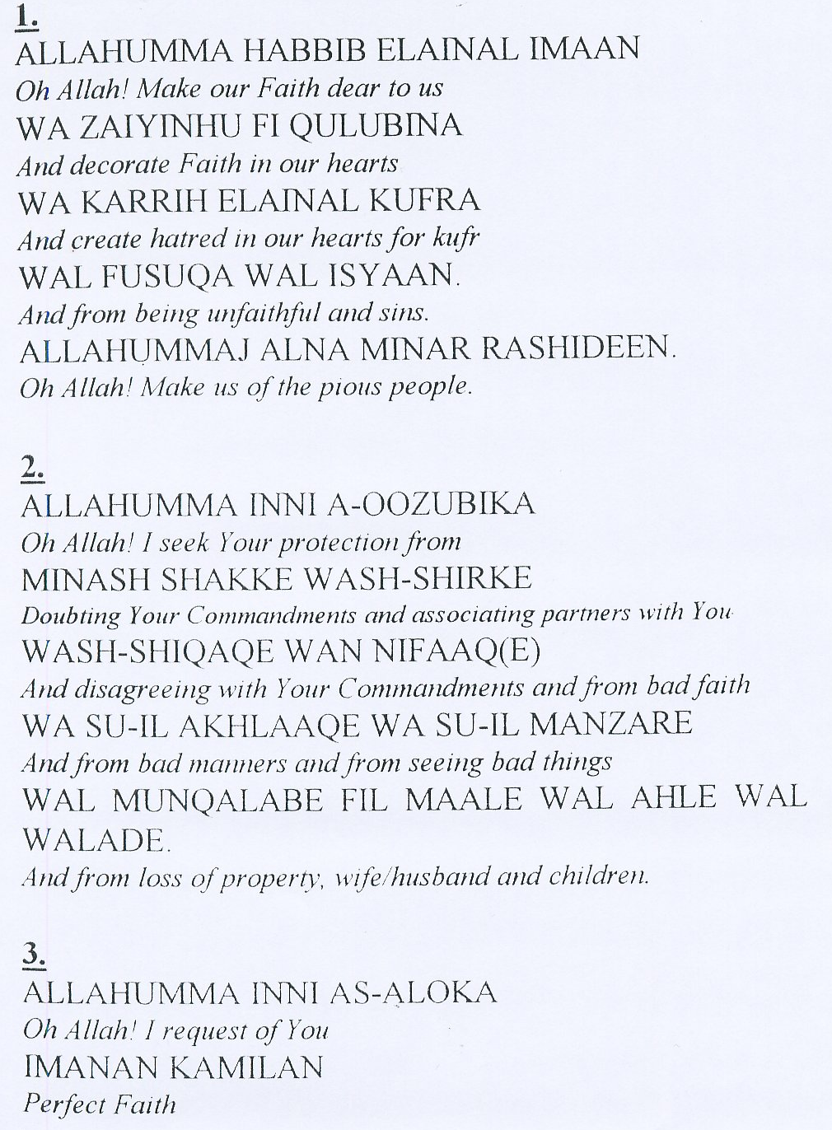
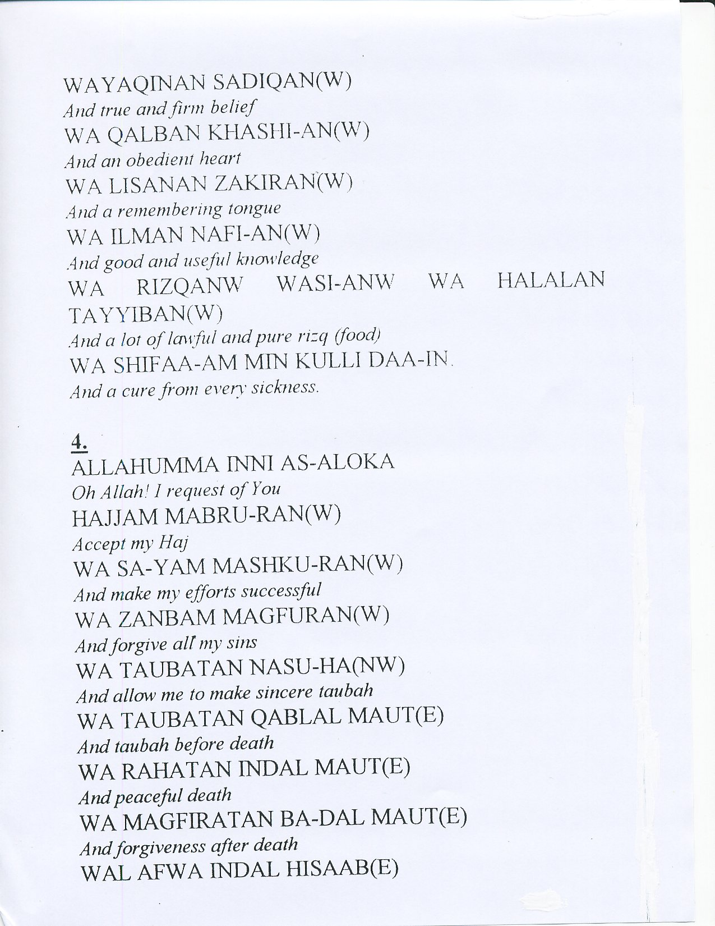
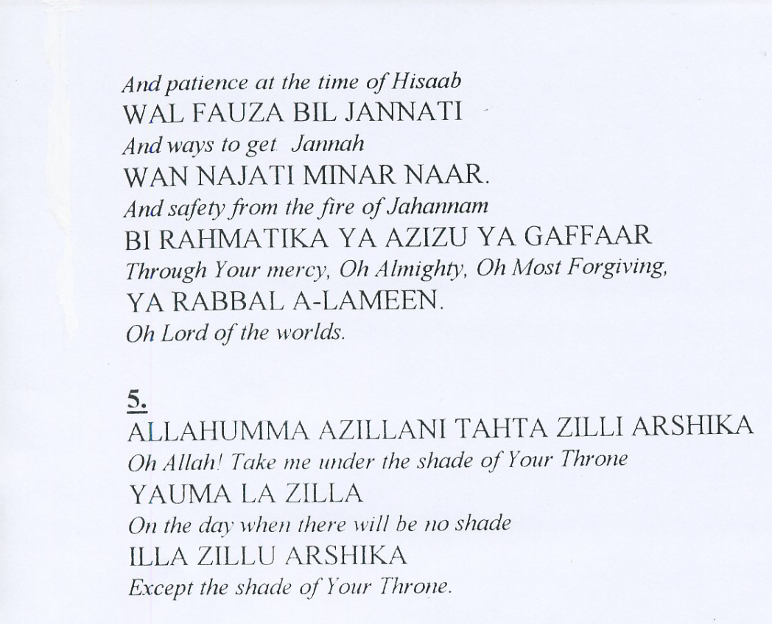

Another Salaam Offering to Rasulullah Sallallahu Alaihi Wasallam:




